Year 5 Religious Education and World Views – Where can we find guidance about how to live our lives?
Christianity – God: Why is it sometimes difficult to do the right thing?
Curriculum aims: Pupils explore Christian beliefs and teachings about sin and temptation (concepts such as The Fall, Original Sin, Free Will, forgiveness and reconciliation). Analyse and ask questions about the story found in Genesis 3, not simply retell it and explore different Christian interpretations of the text. Investigate the importance of forgiveness. Investigate the teachings found in the Lord’s Prayer (penance, confession and reconciliation). Reflect on things that might be seen as ‘temptations’ in modern life. Consider the role of greed and selfishness in leading people astray from doing the right thing – and ask questions about why we/they do things that we/they know are wrong.
Prior learning: The creation story in Genesis 1 (particularly the point that God made the world ‘and saw that it was good’) and with their knowledge of baptism from KS1.

Facts | Vocabulary
Beliefs and Values  - The book of Genesis is the first book of the Bible which explores The Story of Creation when we discover that God created the world ‘and saw that it was good’.  - Chapter 3 of Genesis contains the story of ‘The Fall’ where we learn that Adam and Eve disobeyed God and there were consequences to their actions. This was the ‘Original Sin’  - Some Christians (literal) believe that the accounts of the Bible are fully true and accurate and should be taken literally, whereas some Christians (metaphorical) believe that Genesis 3 is a ‘poetic’ explanation of how evil came into the world.  - What is important for all Christians is that God created the world, and gave humans a special role, status and purpose in it. | Reconciliation – seeking repentance from sins committed.  Temptation – the desire to do something, that could be wrong or unwise.  Morality – the distinction between right and wrong.  Conscience – a person’s moral sense of right and wrong.  Penance - punishment inflicted on oneself as an outward expression of repentance for wrongdoing
Living religious values
- The Lord’s Prayer is found in the Gospel of Matthew in the New Testament. It is the prayer that Jesus told his followers to use, as described in the Gospel of Matthew.
- Christians often use the Lord’s Prayer to feel connected to God. It is used to express adoration, reconciliation, confession and guidance.
- Christians do face temptation in the modern world but try to resist them by following the guidance within the 10 commandments, Lord’s Prayer and within the Bible.
- The 10 commandments are important rules, given by God, which tell Christians how to live.

Shared Human Experience
- Christians use stories (parables and myths) to understand key concepts such as forgiveness and temptations
Search for Personal Meaning
- Sometimes Christians interpret guidance in different ways according to a situation and/or temptation. They may see some guidance as moral absolutes (e.g. do not murder) but some guidance may be less clear (e.g. do not steal – what if they need food to feed a starving child).

Warrington links: | 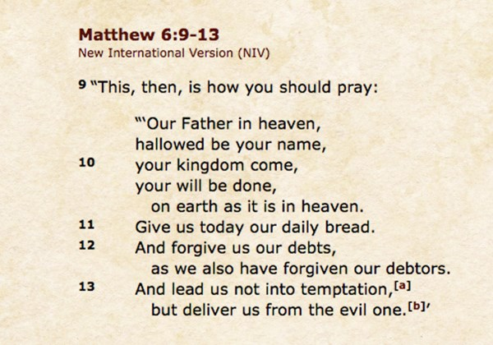
Texts:
https://www.biblegateway.com/passage/?search=Genesis%203&version=NIV
Enrichment:
School visit from a church leaders to talk about the meaning of ‘The Fall’ and the ‘Lord’s Prayer’ in their lives

