Beamont Primary School
Year 3 PSHE Medium Term Plans
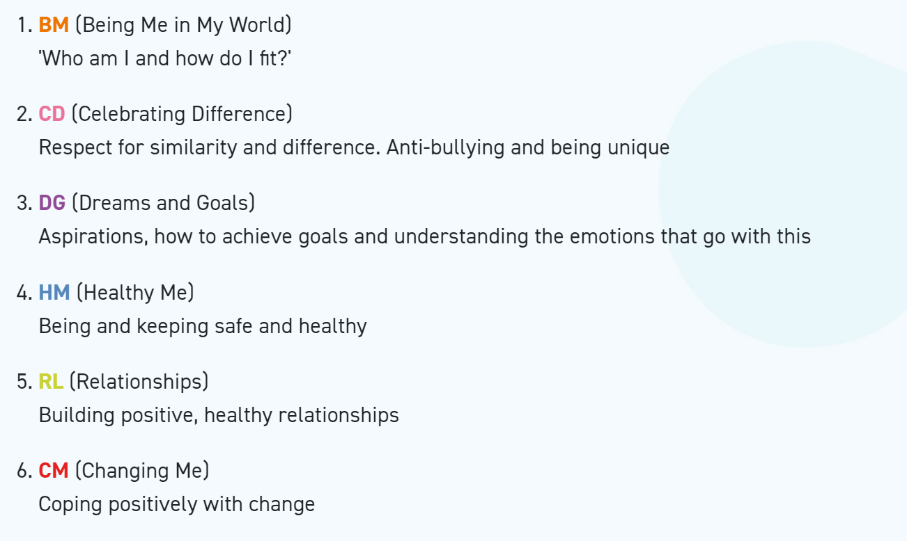
Year 3 Autumn 1 PSHE
Being In My World
Weekly Celebration | Piece | PSHE learning intention | Social and emotional development learning intention | Resources
Help others to feel welcome | 1. Getting to Know Each Other | I recognise my worth and can identify positive things about myself and my achievements.  I can set personal goals  I know how to use my Jigsaw Journal | I value myself and know how to make someone else feel welcome and valued | Jigsaw Charter, Jigsaw Chime, ‘Calm Me’ script, treasure box, Jigsaw Jino, coin and medal template, My Jigsaw Journey, Jigsaw Journals, Jigsaw Jerrie Cat.
Try to make our school community a better place | 2. Our Nightmare School | I can face new challenges positively, make responsible choices and ask for help when I need it | I recognise how it feels to be happy, sad or scared and am able to identify if other people are feeling these emotions | Jigsaw Charter, Jigsaw Chime, ‘Calm Me’ script, Jigsaw Jino, feelings bag with cards, flipchart paper, Nightmare school, My Jigsaw Journey, JigsawJournals, Jigsaw Jerrie Cat.
Think about everyone’s right to learn | 3. Our Dream School | I understand why rules are needed and how they relate to rights and responsibilities | I know how to make others feel valued | Jigsaw Charter, Jigsaw Chime, ‘Calm me’ script, Jigsaw Jino, Nightmare school sheet (from previous Piece), My Jigsaw Journey, Jigsaw Journals, Jigsaw Jerrie Cat.
Care about other people’s feelings | 4. Rewards and Consequences | I understand that my actions affect myself and others and I care about other people’s feelings | I understand that my behaviour brings rewards/consequences | Jigsaw Charter, Jigsaw Chime, ‘Calm me’ script, scenario cards, post-its, My Jigsaw Journey, Jigsaw Journals, Jigsaw Jerrie Cat.
Work well with others | 5. Our Learning  Charter | I can make responsible choices and take action | I can work cooperatively in a group | Jigsaw Charter, Jigsaw Chime, ‘Calm Me’ script, A3 paper, Post-It notes, Sam’s letter, timer, space to display Post-Its, materials for designing a card, Learning Charter, My Jigsaw Journey, Jigsaw Journals, Jigsaw Jerrie Cat.
Choose to follow the Learning Charter | 6. Owning our Learning Charter | I understand my actions affect others and try to see things from their points of view | I am choosing to follow the Learning Charter | Jigsaw Charter, Jigsaw Chime, ‘Calm me’ script, ‘What do we see?’ picture PowerPoint, Learning Charter, Jigsaw Jino, certificates, mood board for last Piece (lesson), My Jigsaw Journey, Jigsaw Journals, Jigsaw Jerrie Cat.

Year 3 Autumn 2 PSHE
Celebrating Difference
Weekly Celebration | Piece | PSHE learning intention | Social and emotional development learning intention | Resources
Accept that  everyone is  different | 1. Families | I understand that everybody’s family is different and important to them | I appreciate my family/the people who care for me | Jigsaw Chime, ‘Calm Me’ script, Jigsaw Jino, Pictures of teacher’s family, ‘Family’ pictures, Slide show, photo frame template, Jigsaw Journals, My Jigsaw Journey, Jigsaw Jerrie Cat.
Include others when working and playing | 2. Family conflict | I understand that differences and conflicts sometimes happen among family members | I know how to calm myself down and can use the ‘Solve it together’ technique | Jigsaw Chime, ‘Calm Me’ script, Letter cards to spell ‘family’ (six cards with a letter on each), PowerPoint slide: Family Conflict, ‘Solve it together’ resource sheet/slides/poster, Family conflict scenario cards, Jigsaw Jino, Jigsaw Journals, My Jigsaw Journey, Jigsaw Jerrie Cat.
Know how to help if someone is being bullied | 3. Witness and feelings | I know what it means to be a witness to bullying | I know some ways of helping to make someone who is bullied feel better | Jigsaw Chime, ‘Calm Me’ script, Jigsaw Jino, Paper for handouts, Jigsaw Song: ‘ There’s a Place’, Resource sheet - Bullying story, Handprint paper chain master, Jigsaw Journals, My Jigsaw Journey, Jigsaw Jerrie Cat.
Try to solve problems | 4. Witness and solutions | I know that witnesses can make the situation better or worse by what they do | I can problem-solve a bullying situation with others | Jigsaw Chime, ‘Calm Me’ script, Sponge ball, Jigsaw Jino, ‘Solve it together’ poster, Scenario cards, PowerPoint with prompt questions, Jigsaw Journals, My Jigsaw Journey, Jigsaw Jerrie Cat.
Try to use kind words | 5. Words that harm | I recognise that some words are used in hurtful ways | I try hard not to use hurtful words (e.g. gay, fat) | Jigsaw Chime, ‘Calm Me’ script, ‘Sticks and stones’ Slide show, Jigsaw Jino, ‘Solve it together’ resource sheet/poster, Jigsaw Journals, My Jigsaw Journey, Jigsaw Jerrie Cat.
Know how to give and receive compliments | 6. Celebrating difference: compliments  Assessment Opportunity Puzzle Outcome: Kites | I can tell you about a time when my words affected someone’s feelings and what the consequences were | I can give and receive compliments and know how this feels | Jigsaw Chime, ‘Calm Me’ script, Kite templates, named post-it notes/slips of paper, Harlon’s story, Jigsaw Journals, Attainment Descriptor Grid, MyJigsaw Journey, Certificates, Jigsaw Jerrie Cat.

Year 3 Spring 1 PSHE
Dreams and Goals
Weekly Celebration | Piece | PSHE learning intention | Social and emotional development learning intention | Resources
Stay motivated when doing something challenging | 1. Dreams and Goals | I can tell you about a person who has faced difficult challenges and achieved success | I respect and admire people who overcome obstacles and achieve their dreams and goals (e.g. through disability) | Jigsaw Chime, ‘Calm Me’ script, Challenge PowerPoint slides, Challenge picture cards (PowerPoint slides), Jigsaw Journals, Jigsaw Jino, Jigsaw Jerrie Cat, My Jigsaw Journey.
Keep trying even when it is difficult | 2. My Dreams and Ambitions | I can identify a dream/ambition that is important to me | I can imagine how I will feel when I achieve my dream/ambition | Jigsaw Chime, ‘Calm Me’ script, PowerPoint slide, Jane Goodall factsheet, Materials for making display flowers, Flower template, Jigsaw Journals, Jigsaw Jino, Jigsaw Jerrie Cat, My Jigsaw Journey.
Work well with a partner or in a group | 3. A New Challenge  Puzzle Outcome: Garden design/decoration | I enjoy facing new learning challenges and working out the best ways for me to achieve them | I can break down a goal into a number of steps and know how others could help me to achieve it | Garden puzzle templates, Jigsaw Chime, ‘Calm Me’ script, Garden PowerPoint, Garden Design Resource Sheet, Jigsaw Journals, Jigsaw Jino, Jigsaw Jerrie Cat, My Jigsaw Journey.
Have a positive attitude | 4. Our New Challenge  Puzzle Outcome: Garden design/decoration | I am motivated and enthusiastic about achieving our new challenge | I know that I am responsible for my own learning and can use my strengths as a learner to achieve the challenge | Jigsaw Jino, Jigsaw Chime, ‘Calm Me’ script, Garden items list, Flipchart and chunky pens, Jigsaw Journals, Jigsaw Jino, Jigsaw Jerrie Cat, My Jigsaw Journey.
Help others to achieve their goals | 5. Our New Challenge - Overcoming Obstacles  Puzzle Outcome: Garden design/decoration | I can recognise obstacles which might hinder my achievement and can take steps to overcome them | I can manage the feelings of frustration that may arise when obstacles occur | ‘Solve it together’ technique poster, Jigsaw Chime, ‘Calm Me’ script, Flipchart and chunky pens, Jigsaw Journals, Jigsaw Jino, Jigsaw Jerrie Cat, My Jigsaw Journey.
Are working hard to achieve their own dreams and goals | 6. Celebrating My Learning  Assessment Opportunity | I can evaluate my own learning process and identify how it can be better next time | I am confident in sharing my success with others and can store my feelings in my internal treasure chest | Garden puzzles, Jigsaw Chime, ‘Calm Me’ script, Self-review PowerPoint slide, Jigsaw Journals, Jigsaw Jino, Self-review template,  Bananas, string, knives, chopping boards, cocktail sticks, Jigsaw Jino, Jigsaw Jerrie Cat, My Jigsaw Journey, Certificates.

Year 3 Spring 2 PSHE
Healthy Me
Weekly Celebration | Piece | PSHE learning intention | Social and emotional development learning intention | Resources
Have made a healthy choice | 1. Being Fit and Healthy | I understand how exercise affects my body and know why my heart and lungs are such important organs | I can set myself a fitness challenge | Jigsaw Chime, ‘Calm Me’ script, PowerPoint slide ‘My body in balance’, PowerPoint ‘Children need to be active for at least one hour a day’, Fitness Challenge Template, Jigsaw Journals, My Jigsaw Journey, Jigsaw Jerrie Cat.
Have eaten a healthy, balanced diet | 2. Being Fit and Healthy | I know that the amount of calories, fat and sugar I put into my body will affect my health | I know what it feels like to make a healthy choice | Jigsaw Chime< ‘Calm Me’ script, Jigsaw Song: ‘Make A Good Decision’, Range of food/drink (some with food labelling that show the amount of energy, fats and sugar). Try to include some heathy and less healthy choices depending on the amount of sugar and fat), ‘How much sugar?’ game, Jigsaw Journals, My Jigsaw Journey, Jigsaw Jerrie Cat.
Have been physically active | 3. What Do I Know About Drugs? | I can tell you my knowledge and attitude towards drugs | I can identify how I feel towards drugs | Jigsaw Chime, ‘Calm Me’ script, A4 white  paper and pen for each child, Draw and Write instruction sheet, Feelings word template, Jigsaw Journal, My Jigsaw Journey, Jigsaw Jerrie Cat.
Have tried to keep themselves and others safe | 4. Being Safe  Puzzle outcome: Keeping safe | identify things, people and places that I need to keep safe from  know some strategies for keeping myself safe, who to go to for help and how to call emergency services | I can express how being anxious or scared feels | Jigsaw Chime, ‘Calm Me’ script, A piece of foreboding music e.g. Theme from Jaws, My Jigsaw Journey, Jigsaw Journal, Jigsaw Jerrie Cat.
Know how to be a good friend and enjoy healthy friendships | 5. Safe or Unsafe | I can identify when something feels safe or unsafe | I can take responsibility for keeping myself and others safe | Jigsaw Chime, ‘Calm Me’ script, PowerPoint  of scared child, Short story templates, Jigsaw Journals, My Jigsaw Journey, Jigsaw Jerrie Cat.
Know how to keep calm and deal with difficult situations | 6. My Amazing Body  Assessment Opportunity | I understand how complex my body is and how important it is to take care of it | I respect my body and appreciate what it does for me | Jigsaw Chime, ‘Calm Me’ script, PowerPoint slide: My amazing body, PowerPoint slides: Example infographic, Other infographic examples (teacher to source online), Paper/ pens, (Optional: computers/tablets for children to design infographic), Jigsaw Journal, My Jigsaw Journey, Certificates, Jigsaw Jerrie Cat.

Year 3 Summer 1 PSHE
Relationships
Weekly Celebration | Pieces | PSHE learning intention | Social and emotional development learning intention | Resources
Know how to make friends | 1. Family Roles and Responsibilities | I can identify the roles and responsibilities of each member of my family and can reflect on the expectations for males and females | I can describe how taking some responsibility in my family makes me feel | Jigsaw Chime, ‘Calm Me’ script, Male/female Jobs PowerPoint, Jigsaw Jino, Male/female/both cards, Sets of the ‘Whose Responsibility?’ cards, Jigsaw Journals, My Jigsaw Journey, Jigsaw Jerrie Cat.
Try to solve friendship problems when they occur | 2. Friendship | I can identify and put into practice some of the skills of friendship eg. taking turns, being a good listener | I know how to negotiate in conflict situations to try to find a win-win solution | Jigsaw Song: ‘RELATIONSHIPS’, Jigsaw Chime, Jigsaw Jino, ‘Calm Me’ script, ‘Donkey’ PowerPoint, Solve it together technique, Mending friendships resource sheet, Friendship conflict scenarios, Jigsaw Journals, My Jigsaw Journey, Jigsaw Jerrie Cat.
Help others to feel part of a group | 3. Keeping Myself Safe Online | I know and can use some strategies for keeping myself safe online | I know who to ask for help if I am worried or concerned about anything online | Jigsaw Jino, Jigsaw Chime, PowerPoint slide of ‘Gaming App’, ‘Top Tips’ cards, ‘Calm me’ script, Jigsaw Journals, My Jigsaw Journey, Jigsaw Jerrie Cat.
Show respect in how they treat others | 4. Being a Global Citizen 1 | I can explain how some of the actions and work of people around the world help and influence my life | I can show an awareness of how this could affect my choices | Jigsaw Chime, ‘Calm Me’ script, Jigsaw Jino,, World map or globe, Bag of items including fair trade chocolate, a T-shirt made in a different country, rice, sugar, PowerPoint: Work in Other Countries Jigsaw, sweetcorn, Mobile phone, Journals, My Jigsaw Journey, Jigsaw Jerrie Cat.
Know how to help themselves and others when they feel upset or hurt | 5. Being a Global Citizen 2 | I understand how my needs and rights are shared by children around the world and can identify how our lives may be different. | I can empathise with children whose lives are different to mine and appreciate what I may learn from them | Jigsaw Chime, ‘Calm Me’ script, Power Point- Children around the world and handouts, A set of the ‘Wants and Needs’ cards cut up, Paper and pens to create posters, Jigsaw Journals, My Jigsaw Learning, Jigsaw Jerrie Cat, Jigsaw Jino.
Know and show what makes a good relationship | 6. Celebrating My Web of Relationships  Puzzle Outcome: Appreciation Streamers | I know how to express my appreciation to my friends and family | I enjoy being part of a family and friendship groups | Jigsaw Jino, Jigsaw Chime, ‘Calm Me’ script, Jigsaw song: ‘RELATIONSHIPS’, Appreciation streamer description sheet, Materials for streamers: strips of coloured paper, pens, wooden batons, tape to secure streamers, Jigsaw Journals, My Jigsaw Journey, Certificates, Jigsaw Jerrie Cat.

Year 3 Summer 2 PSHE
Changing Me
Weekly Celebration | Pieces | PSHE learning intention | Social and emotional development learning intention | Resources
Know who to ask for help if they are worried about change | 5. Family Stereotypes | I can start to recognise stereotypical ideas I might have about parenting and family roles | I can express how I feel when my ideas are challenged and might be willing to change my ideas sometimes | Charades cards, Jigsaw Jino, Jigsaw Chime, ‘Calm Me’ script, Task card resource sheet, Flipchart paper/pens, Jigsaw Journals, My Jigsaw Journey, Jigsaw Jerrie Cat.
Are looking forward to change | 6. Looking Ahead  Assessment Opportunity  Puzzle Outcome: Ribbon Mobiles | identify what I am looking forward to when I move to my next class | start to think about changes I will make next year and know how to go about this | Jigsaw Jino, Jigsaw Chime, ‘Calm Me’ script, Example slide(s) for ‘Ribbon mobiles’, Wooden batons/ sticks, Different coloured paper strips (6 per child), Tape, Jigsaw Journals, My Jigsaw Journey, Certificates, Jigsaw Jerrie Cat.

