Beamont Primary School
Year 4 PSHE Medium Term Plans
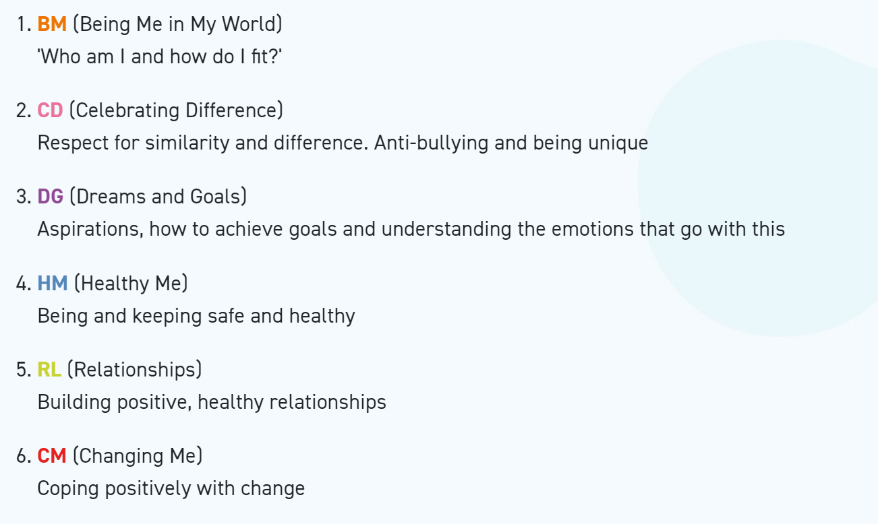
Year 4 Autumn 1 PSHE
Being In My World
Weekly Celebration | Piece | PSHE learning intention | Social and emotional development learning intention | Resources
Help others to feel welcome | 1. Becoming a Class ‘Team’ | I know my attitudes and actions make a difference to the class team  I know how to use my Jigsaw Journal | I know how good it feels to be included in a group and understand how it feels to be excluded  I try to make people feel welcome and valued | Jigsaw Charter, Jigsaw Chime, ‘Calm Me’ script, Jigsaw Jaz, Meet and Greet Bingo resource sheet, Slide show, sponge football, post-its, timer, My Jigsaw Journey, Jigsaw Journals, Jigsaw Jerrie Cat.
Try to make our school community a better place | 2. Being a School Citizen | I understand who is in my school community, the roles they play and how  I fit in | I can take on a role in a group and contribute to the overall outcome | Jigsaw Charter, Jigsaw Chime, ‘Calm Me’ script, sponge football, school community role cards, role cards and blank job description cards, timer, My Jigsaw Journey, Jigsaw Journals, Jigsaw Jerrie Cat.
Think about everyone’s right to learn | 3. Rights, Responsibilities and Democracy | I understand how democracy works through the School Council | I can recognise my contribution to making a Learning Charter for the whole school | Jigsaw Charter, Jigsaw Chime, ‘Calm Me’ script, Jigsaw Jaz, UNCRC Rights of the Child (Unicef leaflet for teacher use), Spot the difference pictures (Articles 12 and 28), UNCRC Resource sheet, My Jigsaw Journey, Jigsaw Journals, Jigsaw Jerrie Cat.
Care about other people’s feelings | 4. Rewards and Consequences | I understand that my actions affect myself and others; I care about other people’s feelings and try to empathise with them | I understand how rewards and consequences motivate people’s behaviour | Jigsaw Charter, Jigsaw Chime, ‘Calm Me’ script, spongeball/orange, scenario cards, Learning Charter, My Jigsaw Journey, Jigsaw Journals, Jigsaw Jerrie Cat.
Work well with others | 5. Our Learning  Charter | I understand how groups come together to make decisions | I can take on a role in a group and contribute to the overall outcome | Jigsaw Charter, Jigsaw Chime, ‘Calm Me’ script, Slide show, What a Mess! scenario, materials for childrens’ posters, Learning Charter, Jigsaw Journals, Jigsaw Jerrie Cat.
Choose to follow the Learning Charter | 6. Owning our Learning Charter | I understand how democracy and having a voice benefits the school community | I understand why our school community benefits from a Learning Charter and can help others to follow it | Jigsaw Charter, Jigsaw Chime, ‘Calm Me’ script, Choices Bingo Sheets, Children’s group posters from previous Piece, Learning Charter, UNCRC Article 28 (see Piece 3), materials for childrens’ posters, certificates, My Jigsaw Journey Jigsaw Journals, Jigsaw Jerrie Cat.

Year 4 Autumn 2 PSHE
Celebrating Difference
Weekly Celebration | Piece | PSHE learning intention | Social and emotional development learning intention | Resources
Accept that  everyone is  different | 1. Judging by Appearances | I understand that, sometimes, we make assumptions based on what people look like | I try to accept people for who they are | Jigsaw Chime, ‘Calm Me’ script, Jigsaw Journals, Character pictures , A pair of cardboard spectacles with coloured lenses (coloured cellophane) for each group, A pair of spectacles with clear lenses for each group , Character answer cards, My Jigsaw Journey, Jigsaw Jerrie Cat.
Include others when working and playing | 2. Understanding influences | I understand what influences me to make assumptions based on how people look | I can question why I think what I do about other people | Jigsaw Jaz, Jigsaw Chime, ‘Calm Me’ script, Optical illusion picture e.g. young/old lady (www.eyetricks.com), Picture of a dog , Response strips, Jigsaw Journals, My Jigsaw Journey, Jigsaw Jerrie Cat.
Know how to help if someone is being bullied | 3. Understanding Bullying | I know that sometimes bullying is hard to spot and I know what to do if I think it is going on but I’m not sure | I know how it might feel to be a witness to and a target of bullying | Jigsaw Chime, ‘Calm Me’ script, Jigsaw Song: ‘There’s a Place’, Maya’s story, Jigsaw Jaz, Flip chart divided into three sections (one per group), Chunky pens, Jigsaw Journals, My Jigsaw Journey, Jigsaw Jerrie Cat.
Try to solve problems | 4. Problem-solving | I can tell you why witnesses sometimes join in with bullying and sometimes don’t tell | I can problem-solve a bullying situation with others | Jigsaw Chime, ‘Calm Me’ script, Jigsaw Jaz, Soft ball, Paper for children’s poster  Pen/pencil for children’s posters  Teacher to source local/national info/websites about bullying on and offline, Jigsaw Journal, My Jigsaw Journey, Jigsaw Jerrie Cat.
Try to use kind words | 5. Special Me  Puzzle outcome: Frames | I can identify what is special about me and value the ways in which I am unique | I like and respect the unique features of my physical appearance | Jigsaw Chime, ‘Calm Me’ script, Jigsaw Jaz, Coloured strips of paper, Glue sticks, Photos of class members, Mirrors, Template photo frames, Jigsaw Journals, My Jigsaw Journey, Jigsaw Jerrie Cat.
Know how to give and receive compliments | 6. Celebrating Difference: how we look  Assessment Opportunity | I can tell you a time when my first impression of someone changed when I got to know them | I can explain why it is good to accept people for who they are | Jigsaw Chime, ‘Calm Me’ script, Jigsaw Jaz, Character cards (to show on whiteboard), Jigsaw Journals , Blue and red spectacle templates, one for each child, Puzzle 2 Attainment Descriptor Grid, My Jigsaw Journey, certificates, Jigsaw Jerrie Cat.

Year 4 Spring 1 PSHE
Dreams and Goals
Weekly Celebration | Piece | PSHE learning intention | Social and emotional development learning intention | Resources
Stay motivated when doing something challenging | 1. Hopes and Dreams | I can tell you about some of my hopes and dreams | I know how it feels to have hopes and dreams | Jigsaw Chime, ‘Calm Me’ script, Story puzzle card, Jigsaw Jaz, Flip chart/ whiteboard, (Optional) Book: ‘Salt in his Shoes’ by Deloris and Roslyn M. Jordan , (Optional) Video clip of Michael Jordan -teacher to source, Mirror cards or pieces of paper shaped like leaves, Collage materials (E.g. beads, ribbons) (Optional if time allows), Jigsaw Journals, My Jigsaw Journey, Jigsaw Jerrie Cat.
Keep trying even when it is difficult | 2. Broken Dreams | I understand that sometimes hopes and dreams do not come true and that this can hurt | I know how disappointment feels and can identify when I have felt that way | Jigsaw Chime, ‘Calm Me’ script, Jigsaw Song: ‘For Me’, Hope and dream scenario cards, Jigsaw Jaz, Mirror dream mobiles from previous Piece, Jigsaw Journals, My Jigsaw Journey, Jigsaw Jerrie Cat.
Work well with a partner or in a group | 3. Overcoming Disappointment | I know that reflecting on positive and happy experiences can help me to counteract disappointment | I know how to cope with disappointment and how to help others cope with theirs | Jigsaw Chime, ‘Calm Me’ script, Jigsaw Song ‘For Me’, Hopes and dreams scenario cards (from previous Piece), Jigsaw Journals, My Jigsaw Journey, Jigsaw Jaz, Jigsaw Jerrie Cat.
Have a positive attitude | 4. Creating New Dreams | I know how to make a new plan and set new goals even if I have been disappointed | I know what it means to be resilient and to have a positive attitude | Jigsaw Chime, ‘Calm Me’ script, Jigsaw Jaz, Dream Cloud resource sheet, Jigsaw Journals, My Jigsaw Journey, Jigsaw Jerrie Cat.
Help others to achieve their goals | 5.Achieving Goals  Puzzle Outcome: Potato People | I know how to work out the steps to take to achieve a goal, and can do this successfully as part of a group | I can enjoy being part of a group challenge | Garden puzzle picture cards, Jigsaw Chime, ‘Calm Me’ script, Invitation to the Potato, Person competition, Large potato for each group, Cocktail sticks, Craft materials (teacher to select) e.g. material scraps, coloured paper, beads, pipe cleaners, Chunky pens, Potato Person Identity Card template, Jigsaw Journals, My Jigsaw Journey, Jigsaw Jaz, Jigsaw Jerrie Cat.
Are working hard to achieve their own dreams and goals | 6. We Did It!  Assessment Opportunity | I can identify the contributions made by myself and others to the group’s achievement | I know how to share in the success of  a group and how to store this success experience in my internal treasure chest | Children’s Potato People/ Identity cards from last lesson (Piece), Jigsaw Chime, ‘Calm Me’ script, Self-review PowerPoint, Flip chart paper, Chunky pens, Jigsaw Journals, My Jigsaw Journey, Camera (optional), Certificates, Jigsaw Jaz, Jigsaw Jerrie Cat.

Year 4 Spring 2 PSHE
Healthy Me
Weekly Celebration | Piece | PSHE learning intention | Social and emotional development learning intention | Resources
Have made a healthy choice | 1. My Friends and Me | I recognise how different friendship groups are formed, how I fit into them and the friends I value the most | I can identify the feelings I have about my friends and my different friendship groups | Jigsaw Chime, ‘Calm Me’ script, Jigsaw Jaz, Concentric circles template (Friendship chart), Jigsaw Journals, Teacher prepared ‘Friendship chart’ example, My Jigsaw Journey, Jigsaw Jerrie Cat.
Have eaten a healthy, balanced diet | 2. Group Dynamics | I understand there are people who take on the roles of leaders or followers in a group, and I know the role I take on in different situations | I am aware of how different people and groups impact on me and can recognise the people I most want to be friends with | Jigsaw Chime, ‘Calm Me’ script, Scenario Slide show, Scenario cards, Jigsaw Journals, My Jigsaw Journey, Jigsaw Jerrie Cat.
Have been physically active | 3. Smoking | I understand the facts about smoking and its effects on health, and also some of the reasons some people start to smoke | I can recognise negative feelings in  peer pressure situations (such as embarrassment, shame, inadequacy and guilt) and know how to act assertively to resist pressure from myself and others | Jigsaw Chime, ‘Calm Me’ script, Jigsaw Jaz, Smoking Facts Picture Puzzle, Scenario cards: What happens next?, Jigsaw Journals, My Jigsaw Journey, Jigsaw Jerrie Cat.
Have tried to keep themselves and others safe | 4. Alcohol | I understand the facts about alcohol and its effects on health, particularly the liver, and also some of the reasons some people drink alcohol | I can recognise negative feelings in  peer pressure situations (such as embarrassment, shame, inadequacy and guilt) and know how to act assertively to resist pressure from myself and others | Jigsaw Chime, ‘Calm Me’ script, Jigsaw  song: Make a good decision, True/False quiz, Slide show: liver and liver facts, Jigsaw Journals, My Jigsaw Journey, Jigsaw Jerrie Cat.
Know how to be a good friend and enjoy healthy friendships | 5. Healthy Friendships  Puzzle Outcome: Healthy Friendships | I can recognise when people are putting me under pressure and can explain ways to resist this when I want | I can identify feelings of anxiety and fear associated with peer pressure | Jigsaw Chime, ‘Calm Me’ script, Jigsaw song: ‘Make a good decision’, Aiden’s story, Flip chart and chunky pens, Jigsaw Journals, My Jigsaw Journey, Jigsaw Jerrie Cat.
Know how to keep calm and deal with difficult situations | 6. Celebrating My Inner Strength and Assertiveness  Assessment Opportunity | I know myself well enough to have a clear picture of what I believe is right and wrong | I can tap into my inner strength and know how to be assertive | Jigsaw Chime, ‘Calm Me’ script, Remote control Slide show, Jigsaw Journals, My Jigsaw Journey, Certificates, Jigsaw Jerrie Cat.

Year 4 Summer 1 PSHE
Relationships
Weekly Celebration | Pieces | PSHE learning intention | Social and emotional development learning intention | Resources
Know how to make friends | 1. Jealousy | I can recognise situations which can cause jealousy in relationships | I can identify feelings associated with jealousy and suggest strategies to problem-solve when this happens | Jigsaw Chime, ‘Calm Me’ script, Jigsaw Jaz, Jealousy Slide show, Situation Cards, Jigsaw Journals, My Jigsaw Journey, Jigsaw Jerrie Cat.
Try to solve friendship problems when they occur | 2. Love and Loss | I can identify someone I love and can express why they are special to me | I know how most people feel when they lose someone or something they love | Jigsaw Chime, ‘Calm Me’ script, Recommended: Jigsaw in Focus book ‘Can You Hear the Sea?’ (available to purchase from the Jigsaw Online Shop), Flipchart prepared with scenarios, Post-it notes, Jigsaw Jaz, Jigsaw Journals, Jigsaw Jaz’s memory box (a box filled with items e.g. shell, pine cone, pebbles, photos, other ‘precious’ objects), My Jigsaw Journey, Jigsaw Jerrie Cat.
Help others to feel part of a group | 3. Memories  Puzzle outcome: Memory Box | I can tell you about someone I know that I no longer see | I understand that we can remember people even if we no longer see them | Jigsaw Chime, ‘Calm Me’ script, Jigsaw Jaz, Jigsaw Jaz’s memory box (from last Piece)  Mini whiteboards/ pens (or paper and pens), Slide show: photo of Tammy, Candle, Paper and pens for creating poems and pictures, Jigsaw Journals, My Jigsaw Journey, Jigsaw Jerrie Cat.
Show respect in how they treat others | 4. Getting on and Falling Out | I can recognise how friendships change, know how to make new friends and how to manage when I fall out with my friends | I know how to stand up for myself and how to negotiate and compromise | Jigsaw Chime, ‘Calm Me‘ script, Mini whiteboards and pens, or paper and pens, ‘Make Friends, Break Friends?’ scenario cards,  Slide show, Jigsaw Jaz, Jigsaw Journals, My Jigsaw Journey, Jigsaw Jerrie Cat.
Know and show what makes a good relationship | 6. Celebrating My Relationships with People and Animals  Assessment Opportunity | I know how to show love and appreciation to the people and animals who are special to me | I can love and be loved | Jigsaw Jaz, Jigsaw Chime, ‘Calm Me’ script, Squares of strong coloured paper or card 20cm square, A range of collage materials and glue, Jigsaw Journals, My Jigsaw Journey, Certificates, Jigsaw Jerrie Cat.

Year 4 Summer 2 PSHE
Changing Me
Weekly Celebration | Pieces | PSHE learning intention | Social and emotional development learning intention | Resources
Understand  and respect the changes that they see in other people | 4. Circles of Change  Puzzle Outcome: Circles of Change | I know how the circle of change works and can apply it to changes I want to make in my life | I am confident enough to try to make changes when I think they will benefit me | Jigsaw Song: ‘A New Day’, Jigsaw Jaz, Jigsaw Chime, ‘Calm Me’ script, Season tree pictures, Slide show, Circle of Change diagram/template, Split pins, Cardboard arrows, Jigsaw Journals, My Jigsaw Journey, Jigsaw Jerrie Cat.
Know who to ask for help if they are worried about change | 5. Accepting Change | I can identify changes that have been and may continue to be outside of my control that I learnt to accept | I can express my fears and concerns about changes that are outside of my control and know how to manage these feelings positively | Emotions cards, Slide show of environmental change, Change Scenario cards, Jigsaw Chime, ‘Calm Me’ script, Jigsaw Journals, My Jigsaw Journey, Jigsaw Jerrie Cat.
Are looking forward to change | 6. Looking Ahead  Assessment Opportunity | I can identify what I am looking forward to when I move to a new class | I can reflect on the changes I would like to make next year and can describe how to go about this | Jigsaw Jaz, Jigsaw Chime, The same objects used for the ‘Bag of Tricks’ activity in lesson 3, laid out on a tray or the floor, A piece of cloth, ‘Calm Me’ script, Jigsaw Jaz’s post box, Circle of Change templates, Jigsaw Journals, My Jigsaw Journey, Certificates, Jigsaw Jerrie Cat.

