Beamont Primary School
Year 6 PSHE Medium Term Plans
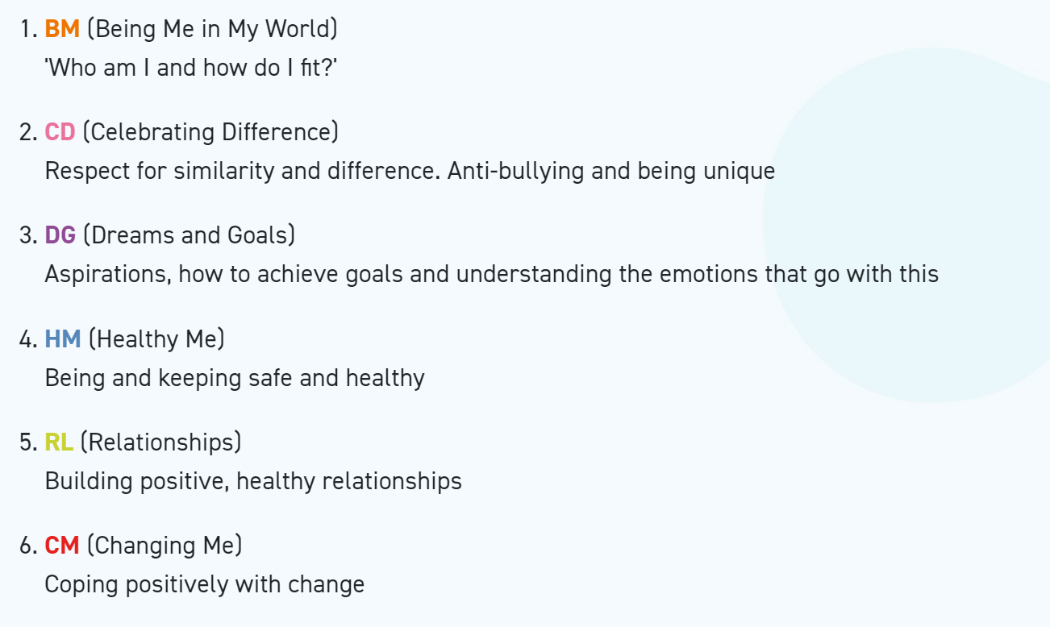
Year 6 Autumn 1 PSHE
Being In My World
Weekly Celebration | Piece | PSHE learning intention | Social and emotional development learning intention | Resources
Help others to feel welcome | 1. My Year Ahead | I can identify my goals for this year, understand my fears and worries about the future and know how to express them  I know how to use my Jigsaw Journal | I feel welcome and valued and know how to make others feel the same | Jigsaw Charter, Jigsaw Chime, ‘Calm Me’ script, Meet and Greet Bingo sheets, Slide show, Teacher to source photo of J.K.Rowling from online source, Spiral and flag templates, Jigsaw Jem, My Jigsaw Journey, Jigsaw Journals, Jigsaw Jerrie Cat.
Try to make our school community a better place | 2. Being a Global Citizen 1 | I know that there are universal rights for all children but for many children these rights are not met | I understand my own wants and needs and can compare these with children in different communities | Jigsaw Charter, Jigsaw Chime, ‘Calm Me’ script, Slide show, chocolate/sweets as prizes, My Jigsaw Journey, Jigsaw Journals, Jigsaw Jem, Jigsaw Jerrie Cat.
Think about everyone’s right to learn | 3. Being a Global Citizen 2 | I understand that my actions affect other people locally and globally | I understand my own wants and needs and can compare these with children in different communities | Jigsaw Charter, Jigsaw Chime, ‘Calm Me’ script, Jigsaw Jem, strips of paper (one for each child), Slide show, Maslow's Triangle template, My Jigsaw Journey, Jigsaw Journals, Jigsaw Jerrie Cat.
Care about other people’s feelings | 4. The Learning Charter | I can make choices about my own behaviour because I understand how rewards and consequences feel and  I understand how these relate to my rights and responsibilities | I understand that my actions affect myself and others; I care about other people’s feelings and try to empathise with them | Jigsaw Charter, Jigsaw Chime, ‘Calm Me’ script, treasure box with rattly treasure, example completed Learning Charter, Learning Charter template, My Jigsaw Journey, Jigsaw Journals, Jigsaw Jerrie Cat, Jigsaw Jem.
Work well with others | 5. Our Learning Charter | I understand how an individual’s behaviour can impact on a group | I can contribute to the group and understand how we can function best as a whole | Jigsaw Charter, Jigsaw Chime, ‘Calm Me’ script, anti-social behaviour scenario, role-play cards, Corner school learning charter, My Jigsaw Journey, Jigsaw Journals, Jigsaw Jem, Jigsaw Jerrie Cat.
Choose to follow the Learning Charter | 6. Owning our Learning Charter | I understand how democracy and having a voice benefits the school community | I understand why our school community benefits from a Learning Charter and how I can help others to follow it by modelling it myself | Jigsaw Charter, Jigsaw Chime, ‘Calm Me’ script, Jigsaw Jem, Learning Charter, My Jigsaw Journey, certificates, Jigsaw Journals, Jigsaw Jerrie Cat.

Year 6 Autumn 2 PSHE
Celebrating Difference
Weekly Celebration | Piece | PSHE learning intention | Social and emotional development learning intention | Resources
Accept that  everyone is  different | 1. Am I Normal? | I understand there are different perceptions about what normal means | I can empathise with people who are different | Jigsaw Chime, ‘Calm Me’ script, Slide show, Jigsaw Jem, Jigsaw Journals, My Jigsaw Journey, Jigsaw Jerrie Cat.
Include others when working and playing | 2. Understanding Difference | I understand how being different could affect someone’s life | I am aware of my attitude towards people who are different | Jigsaw Chime, ‘Calm Me’ script, Life story of Robert/Roberta Cowell, Community pictures, Jigsaw Jem, A3 paper or sugar paper, photos of other trans people, Jigsaw Journals, My Jigsaw Journey, Jigsaw Jerrie Cat.
Know how to help if someone is being bullied | 3. Power Struggles | I can explain some of the ways in which one person or a group can have power over another | I know how it can feel to be excluded or treated badly by being different in some way | Jigsaw Chime, ‘Calm Me’ script, Teacher to source bullying support information, Jigsaw Song: ‘There’s a Place’ Power scenario resource sheet, Jigsaw Journals, My Jigsaw Journey, Jigsaw Jerrie Cat.
Try to solve problems | 4. Why Bully | I know some of the reasons why people use bullying behaviours | I can tell you a range of strategies  for managing my feelings in bullying situations and for problem-solving when I’m part of one | Jigsaw Chime, ‘Calm me’ script, Jigsaw Jem, Slide show, Scenario cards, Jigsaw Journals, My Jigsaw Journey, Jigsaw Jerrie Cat.
Try to use kind words | 5. Celebrating Difference  Puzzle Outcome: Admiration Accolades | I can give examples of people with disabilities who lead amazing lives | I appreciate people for who they are | Jigsaw Chime, ‘Calm Me’ script, Ball, Jigsaw Jem, Slide show, YouTube clip - Paralympians (teacher to source), Jigsaw Journals, My Jigsaw Journey, Jigsaw Jerrie Cat.
Know how to give and receive compliments | 6. Celebrating Difference  Assessment Opportunity | I can explain ways in which difference can be a source of conflict and a cause for celebration | I can show empathy with people in either situation | Jigsaw Chime, ‘Calm Me’ script, Jigsaw  Jem, Slide show: pictures of conflict/ celebration, Peer assessment sheet, Draw cards (two alternative sets to choose from), Jigsaw Journals, My Jigsaw Journey, Certificates, Jigsaw Jerrie Cat.

Year 6 Spring 1 PSHE
Dreams and Goals
Weekly Celebration | Piece | PSHE learning intention | Social and emotional development learning intention | Resources
Stay motivated when doing something challenging | 1. Personal Learning Goals | I know my learning strengths and can set challenging but realistic goals for myself (e.g. one in-school goal and one out-of- school goal) | I understand why it is important to stretch the boundaries of my current learning | Jigsaw Chime, ‘Calm Me’ script, Strength cards, Jigsaw Jem, Goal cards template, Jigsaw Journals, My Jigsaw Journey, Jigsaw Jerrie Cat.
Keep trying even when it is difficult | 2. Steps to Success | I can work out the learning steps I need to take to reach my goal and understand how to motivate myself to work on these | I can set success criteria so that I will know whether I have reached my goal | Jigsaw Chime, ‘Calm Me’ script, Jigsaw Song: ‘For Me’, Slide show, Totem pole goal-setting template, Jigsaw Journals, My Jigsaw Journey, Jigsaw Jem, Jigsaw Jerrie Cat.
Work well with a partner or in a group | 3. My Dream For the World  Puzzle outcome: Flags/ bunting | I can identify problems in the world that concern me and talk to other people about them | I recognise the emotions I experience when I consider people in the world who are suffering or living in difficult situations | Jigsaw Jem, Jigsaw Chime, ‘Calm Me’  script, Global issue photo cards , World Map, Jigsaw Journals, Coloured triangular pieces of material and string, Slide show, My Jigsaw Journey, Jigsaw Jerrie Cat.
Have a positive attitude | 4. Helping to Make a Difference  Puzzle outcome: Fundraising event | I can work with other people to help make the world a better place | I can empathise with people who are suffering or who are living in difficult situations | Sponge ball, Timer, Jigsaw Chime, ‘Calm Me’ script, Global issue photo cards (from Piece/ lesson 3) , Recommended: Video clips of TV charity events/ charity TV adverts (Teacher to source), Project plan sheet, Jigsaw Journals, Jigsaw Jem, My Jigsaw Journey, Jigsaw Jerrie Cat.
Help others to achieve their goals | 5.Helping to Make a Difference | I can describe some ways in which I can work with other people to help make the world a better place | I can identify why I am motivated to do this | Sponge ball, Timer, Jigsaw Chime, ‘Calm Me’ script, Group Project plans from last piece/ lesson, Jigsaw Journals, Jigsaw Jem, My Jigsaw Journey, Jigsaw Jerrie Cat.
Are working hard to achieve their own dreams and goals | 6. Recognising Our Achievements  Assessment Opportunity | I know what some people in my class like or admire about me and can accept their praise | I can give praise and compliments to other people when I recognise their contributions and achievements | Jigsaw Jem, Jigsaw Chime, ‘Calm Me’ script, Post-it notes, Achievement card template, Jigsaw Journals, My Jigsaw Journey, Certificates, Jigsaw Jerrie Cat.

Year 6 Spring 2 PSHE
Healthy Me
Weekly Celebration | Piece | PSHE learning intention | Social and emotional development learning intention | Resources
Have made a healthy choice | 1. Taking responsibility for my health and well-being | I can take responsibility for my health and make choices that benefit my health and well-being | I am motivated to care for my physical and emotional health | Jigsaw Chime, ‘Calm Me’ script, Guess what I am? Slide show, Taking responsibility role play cards, Jigsaw Journals, My Jigsaw Journey, Jigsaw Jem, Jigsaw Jerrie Cat.
Have eaten a healthy, balanced diet | 2. Drugs | I know about different types of drugs and their uses and their effects on the body particularly the liver and heart | I am motivated to find ways to be happy and cope with life’s situations without using drugs | Jigsaw Chime, ‘Calm Me’ script, Slide show, PowerPoint slide : Drug categories, Drug groups sorting resource, Teacher resource sheet (Information only), My Jigsaw Journey, Jigsaw Journal, Jigsaw Jem, Jigsaw Jerrie Cat.
Have been physically active | 3. Exploitation | I understand that some people can be exploited and made to do things that are against the law | I can suggest ways that someone who is being exploited can help themselves | Jigsaw Chime, ‘Calm Me’ script, Ava and Kiran’s story, Pens of two different colours (ideally red and green) enough for each group, Slide show, Jigsaw Journals, My Jigsaw Journey, Jigsaw Jem, Jigsaw Jerrie Cat.
Have tried to keep themselves and others safe | 4. Gangs | I know why some people join gangs and the risks this involves | I can suggest strategies someone could use to avoid being pressurised | Jigsaw Chime, ‘Calm Me’ script, Slide show, ‘Gangs are...’ game cards, Jigsaw Journals, My Jigsaw Journey, Jigsaw Jem, Jigsaw Jerrie Cat.
Know how to be a good friend and enjoy healthy friendships | 5. Emotional and Mental Health | I understand what it means to be emotionally well and can explore people’s attitudes towards mental health/illness | I know how to help myself feel emotionally healthy and can recognise when I need help with this | Jigsaw Chime, ‘Calm Me’ script, Jigsaw Jem, Slide show, My emotional well template, Jigsaw Journals, My Jigsaw Journey, Jigsaw Jerrie Cat.
Know how to keep calm and deal with difficult situations | 6. Managing Stress and Pressure  Puzzle Outcome: Healthy Body, Healthy Mind  Assessment Opportunity | I can recognise stress and the triggers that cause this and I understand how stress can cause drug and alcohol misuse. | I can use different strategies to manage stress and pressure | Jigsaw Chime, ‘Calm Me’ script, Slide show, Cube template (copied on to card), Glue, Jigsaw Journals, My Jigsaw Journey, Certificates, Jigsaw Jem, Jigsaw Jerrie Cat.

Year 6 Summer 1 PSHE
Relationships
Weekly Celebration | Pieces | PSHE learning intention | Social and emotional development learning intention | Resources
Know how to make friends | 1. What is Mental Health? | I know that it is important to take care of my mental health | I understand that people can get problems with their mental health and that it is nothing to be ashamed of | Jigsaw Chime, ‘Calm Me‘ script, Post it notes or slips of paper, Slide show, ‘Mental health definition’, Optional: Set of balance scales, ‘Situation cards’, Jigsaw Jem, Jigsaw Journals, My Jigsaw Journey, Jigsaw Jerrie Cat.
Try to solve friendship problems when they occur | 2. My Mental Health | I know how to take care of my mental health | I can help myself and others when worried about a mental health problem | Jigsaw Chime, ‘Calm Me‘ script, Ball of string or wool, Slide show, actions cycle’ and handouts, Scenario cards, Jigsaw Journals, My Jigsaw Journey, Jigsaw Jem, Jigsaw Jerrie Cat.
Help others to feel part of a group | 3. Love and Loss | I understand that there are different stages of grief and that there are different types of loss that cause people to grieve | I can recognise when I am feeling those emotions and have strategies to manage them | 20 random objects on a tray, Jigsaw Chime, ‘Calm Me’ script, Loss or change cards, Post-its, Slide show, Optional: Jigsaw in Focus book: ‘Can You Hear the Sea?’ available to purchase from the Jigsaw online store, Scenario cards, Jigsaw Journals, My Jigsaw Journey, Jigsaw Jem, Jigsaw Jerrie Cat.
Show respect in how they treat others | 4. Power and Control | I can recognise when people are trying to gain power or control | I can demonstrate ways I could stand up for myself and my friends in situations where others are trying to gain power or control | Jigsaw Chime, ‘Calm Me’ script, Jigsaw Jem, Slide show, Power and Control scenario cards, Jigsaw Journals, My Jigsaw Journey, Jigsaw Jerrie Cat.
Know how to help themselves and others when they feel upset or hurt | 5. Being Online: Real or Fake? Safe or Unsafe? | I can judge whether something online is safe and helpful for me | I can resist pressure to do something online that might hurt myself or others | Jigsaw Chime, ‘Calm Me’ script, Jigsaw Jem, Calculators, Slide show, ‘Online scenario cards’, Jigsaw Journals, My JigsawJourney, Jigsaw Jerrie Cat.
Know and show what makes a good relationship | 6. Using Technology Responsibly  Puzzle Outcome: Internet Safety Presentation  Assessment Opportunity | I can use technology positively and safely to communicate with my friends and family | I can take responsibility for my own safety and well-being | Jigsaw Chime, ‘Calm Me’ script, Jigsaw  Jem, Slide show, Planning sheets for Internet safety PowerPoint presentation, Jigsaw Journals, My Jigsaw Journey, Certificates, Jigsaw Jerrie Cat.

Year 6 Summer 2 PSHE
Changing Me
Weekly Celebration | Pieces | PSHE learning intention | Social and emotional development learning intention | Resources
Understand that everyone is unique and special | 1. My Self Image | I am aware of my own self-image and how my body image fits into that | I know how to develop my own self esteem | Classroom labels (letter A- D), ‘Time and Money’ Slide show, Jigsaw Chime, ‘Calm me’ script, Flip chart and pens, Unhelpful/helpful resource, Jigsaw Journals, My Jigsaw Journey, Jigsaw Jerrie Cat.
Know who to ask for help if they are worried about change | 5. Real self and ideal self | I am aware of the importance of a positive self-esteem and what I can do to develop it | I can express how I feel about my self-image and know how to challenge negative ‘body-talk’ | Jigsaw Chime, ‘Calm me’ script, Cosmetic items: a tube of toothpaste, a hair product for men, an item of make- up, Slide show, ‘Real’ self/’ideal’ self templates – 2 copies per child, Different coloured pens, Jigsaw Journals, My Jigsaw Journey, Jigsaw Jem, Jigsaw Jerrie Cat.
Are looking forward to change | 6. The Year Ahead | I can identify what I am looking forward to and what worries me about the transition to secondary school /or moving to my next class. | I know how to prepare myself emotionally for the changes next year. | Jigsaw Jem, Jigsaw Chime, ‘Calm Me’ script, Slide show, Paper and pens, Optional: Blank T-shirts, Optional: Fabric pens, Jigsaw Journals, My Jigsaw Journey, Certificates, Jigsaw Jerrie Cat.

