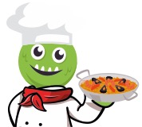
Term |  | Stage 1 | Stage 2 | Stage 3 | Stage 4
Autumn | 1 | - Greetings and Feelings  - Numbers 0-10  - Colours | - Welcome to the school | - Saying more about ourselves  - School subjects and opinions | - Time  - Daily routine
 | 2 | - Days  - Months | - Classroom/robot commands  - Town and shops | - In the city  - Buying a present | - House
Spring | 1 | - Animals | - Family  - Alien Faces | - Going to the market | - Sports
 | 2 | - 11-20 and ages | - Parts of the body and monsters | - Clothes and fashion shows | - Hobbies and this is me
Summer | 1 | - Hungry giant | - I don’t feel well  - Jungle animals | - Planets  - Travellers ID | - Café dialogues and foods  - In the restaurant
 | 2 | - Gingerbread man questions and answers  - Picnics | - Weather  - Ice Creams | - Seaside | - N/A

