Year 1 Observational drawing -sketching
Prior Learning: pencil, pencil grip, abstract art
Facts | Vocabulary
- Drawing is:  - A picture or diagram made with pencil, pen or crayon | - Drawing  - Pablo Picasso  - Technique  - Portrait  - Linear  - Scumbling  - Side stroke  - Feathering  - Cubism  - Influenced by/ Inspired b
- Pablo Picasso:
- Born in Spain in 1881
- Liked to use lots of colours and lines
- Painter, sculptor, print-maker, stage-designer, poet

- Explore texture using pencil:
- Linear – drawing using only narrow lines
- Scumbling – shading using tiny circles and scribbles
- Side stroke – using the side of a pencil with light pressure
- Feathering – a series of short lines that appear to be a single line

- Portraits:  - A painting or drawing of a person, especially only their face or head and shoulders | 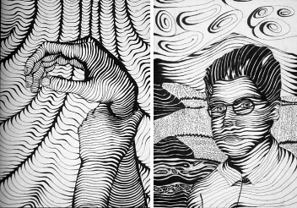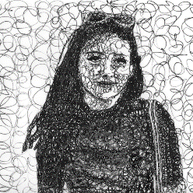  Linear Scumbling  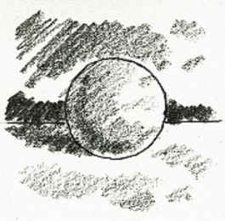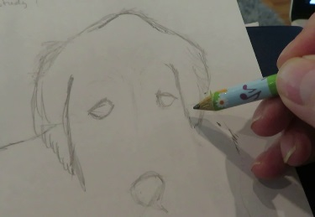  Side stroke Feathering  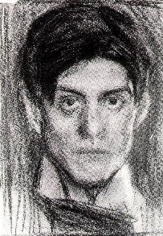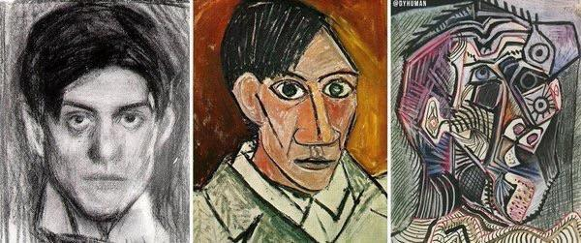  Self-portrait –aged 18 Evolution of self-portraits  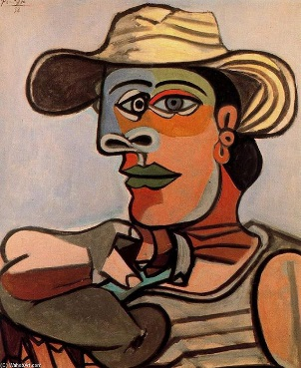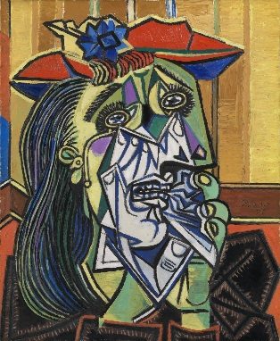  The Sailor The Weeping Woman
- Cubism:
- When an artist draws or paints an object from many angles in the same picture

- Creating our own cubism artwork:
- Pencil outline
- Paint
- Black outline

- Comparing our portraits to Picasso’s:
- Similarities – what things are the same
- Differences – what things are different
- The Sailor
- The Weeping Woman

- The wider influences of portraits:

Youtube:
Pablo Picasso information:
https://www.tate.org.uk/art/artists/pablo-picasso-1767

https://www.bbc.com/bitesize/clips/zdfgkqt

Evolution of self-portraits
https://www.tes.com/teaching-resource/paul-klee-11048977
https://www.boredpanda.com/pablo-picasso-self-portrait-style-evolution/?utm_source=google&utm_medium=organic&utm_campaign=organic

Recreating cubism artwork step by step:
https://www.google.com/search?q=cubism+ks1&safe=strict&rlz=1C1GCEA_enGB856GB856&source=lnms&tbm=isch&sa=X&ved=0ahUKEwjh1vSJnpbjAhWVoFwKHcyXAXsQ_AUIECgB&biw=1034&bih=616#imgrc=I2hjocNOk7ERNM:

