Year 1 Pattern and Prints
Prior Learning: knowledge of primary colours, pencil, colour, paint, artist, pencil grip,
Facts | Vocabulary
- Pattern is:  - A repeated decorative design  - A regular repeated design or reoccurring sequence | - Pattern  - Paul Klee  - Abstract  - Line  - Primary colours – red, yellow, blue  - Secondary colours – orange, green, purple  - Mixing  - Shape  - Block printing  - Influenced by/ Inspired by
- Paul Klee:
- Born in Switzerland in 1879
- Liked to use lots of colours and lines
- Abstract artist

- Abstract art:
- Mainly uses colours, shapes, lines and marks
- The artist shows their interpretation of something
- It might appear as an unrealistic image
- Lines:  - Straight – a line in the same direction that connects two points  - Curved – a smooth line that curves in different directions  - Zig-zag – a line that has lots of short, sharp turns | 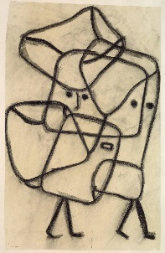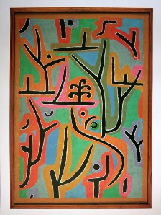  Burderned Child Park Near Lu  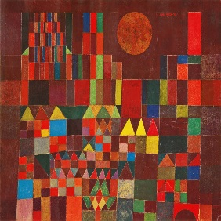  Castle and the Sun  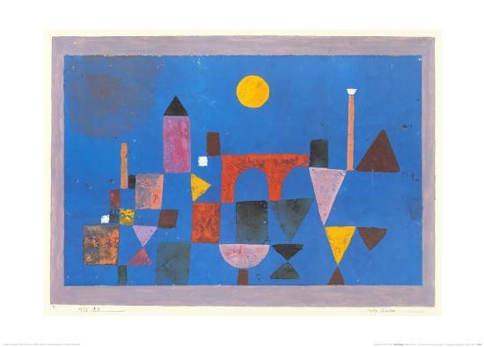  Red Bridge  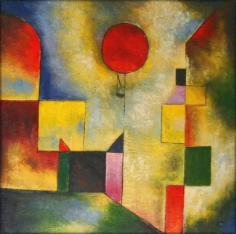  Red Balloon
- Colour:
- Primary – red, yellow, blue
- Secondary – orange, green, purple
- Mixing – red & yellow – orange
yellow & blue – green
red & blue – purple

- Shape
- Names of shapes – square, rectangles, triangle, circle, semi-circle,
- Block printing – a technique for printing images or patterns

- Creating our own patterns/artwork using Paul Klee’s artwork as inspiration:
- Castle and the Sun
- Red Bridge
- Red Balloon

- Patterns in other cultures:
- Henna – a reddish-brown dye used to decorate the body
- Rangoli Patterns – patterns drawn on the floor by Hindus during Diwali
Youtube:
Paul Klee information
https://www.tate.org.uk/art/artists/paul-klee-1417

https://www.tes.com/teaching-resource/paul-klee-11048977

http://primaryfacts.com/831/10-paul-klee-facts/

Recreating a castle using 2D shapes:
https://www.youtube.com/watch?v=lVfnesiV_cg

