Year 1 Texture and Collage
Prior Learning: senses, touch, feel, cut, stick, artist
Facts | Vocabulary
- Texture is:  - How something feels when it is touched | - Texture  - Henri Matisse  - Collage  - Technique  - Tearing  - Cutting  - Overlapping  - Sticking  - Materials  - Influenced by/ Inspired by
- Henri Matisse:
- Born in France in 1869
- Liked to use lots of bold colours
- Painter, printer, sculptor and made collages
- At 72, he couldn’t paint due to illness and created collages

- Collage:
- A piece of art made by sticking different materials onto a backing
- How to collage (technique):  - Tearing – ripping materials using force  - Cutting – using scissors to get neat edges  - Overlapping – cover something partly by joining over the top  - Sticking – attaching firmly with glue or tape | 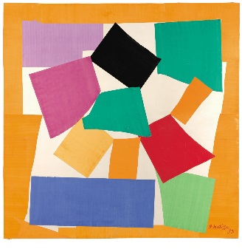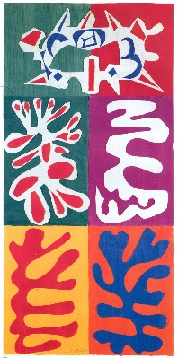  The Snail Panel with Mask  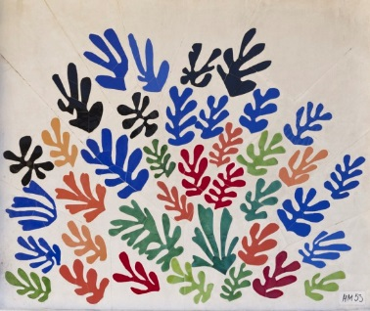  The Sheaf  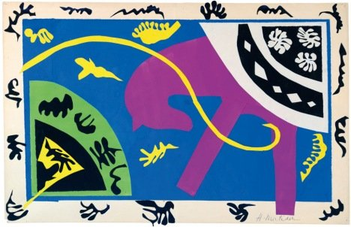  The Horse, the Rider and the Clown  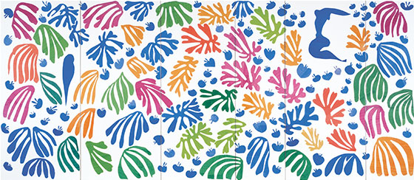  The Parakeet and the Mermaid
- Materials:
- Paper
- Card
- Foil
- Tissue
- Felt

- Creating our own artwork using Henri Matisse’s artwork as inspiration and a range of materials and textures:
- The Horse, the Rider and the Clown
- The Parakeet and the Mermaid

- Collage/texture in other cultures:

Youtube:
Henri Matisse information
https://www.tate.org.uk/art/artists/henri-matisse-1593

https://www.youtube.com/watch?v=kRkdY8VQx1c

https://www.tate.org.uk/kids/explore/kids-view/meet-matisse

Recreating Matisse’s artwork:
https://www.youtube.com/watch?v=G8hvBhqoJZQ
https://www.tate.org.uk/kids/make/cut-paste/collage-matisse-snail

Matisse in action
https://www.youtube.com/watch?v=GN0okOq8Hyc

