Year 1 Structures (freestanding structures)
Prior Learning: Experience of using construction kits to build walls, towers and frameworks. Experience of using basic tools e.g. scissors or hole punches with construction materials e.g. plastic, card. Experience of different methods of joining card and paper.
Future learning: LKS2 – shell structures – use of nets of 3D shapes and develop strengthening and stiffening techniques. UKS2 – Frame structures, development of triangulation.

Facts | Vocabulary
- What is a freestanding structure?  A freestanding structure is a structure that stands on its own foundation or base without attachment to anything else. | - Stability – in relation to a freestanding structure, the extent to which it is likely to fall over if a force is applied.  - Base – the lowest part or edge of something, especially the part on which it rests or is supported.  - Edge – the outside limit of an object, area, or surface.  - Surface - the outside part or uppermost layer of something
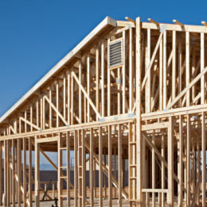
- What is a framework?

A framework is the essential supporting structure of a building, vehicle or object.

- Technical knowledge and understanding  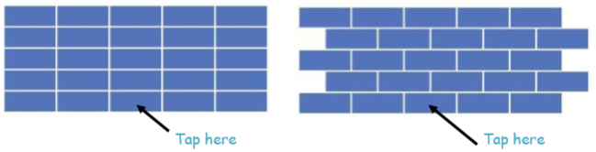  Build walls with these different patterns. Tap away the centre brick in the bottom row of each wall in turn. What happens? Which wall is the strongest? | Freestanding structures  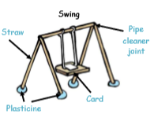  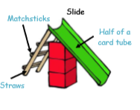
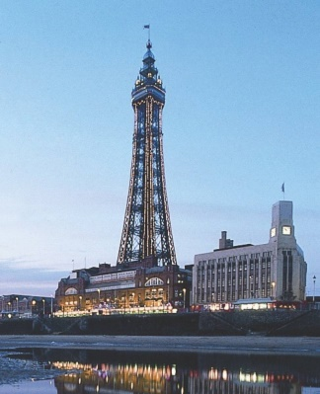
- Local freestanding structure

Blackpool Tower is the 120th tallest freestanding tower in the world. It opened in 1894 and stands at a height of 158m.
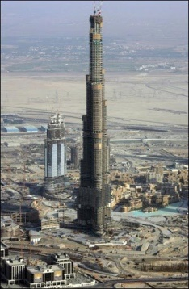
- Tallest freestanding structure

The Burj Khalifa in Dubai is the world’s tallest freestanding structure. The skyscraper stands at 830m tall.

