Year 1 Food (preparing fruit and vegetables)
Prior Learning: Experience of common fruit and vegetables, undertaking sensory activities i.e. appearance, taste and smell. Experience of cutting soft fruit and vegetables.
Future learning: Further food technology in KS1: To understand where fruit and vegetables come from. LKS2: To further develop the use of appropriate kitchen equipment and utensils.

Facts | Vocabulary
- Basic equipment.  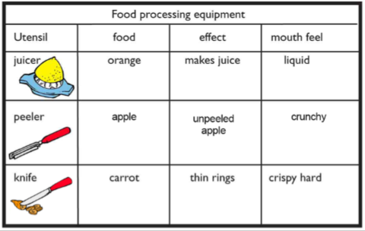 | - Texture – how something feels or looks.  - Fruit - the sweet and fleshy product of a tree or other plant that contains seed and can be eaten as food.  - Vegetables - plant used for food.  - Sensory evaluation – subjective testing of foods where senses are used to evaluate qualities such as appearance, smell, taste, texture (mouth feel).
- Food processing skills
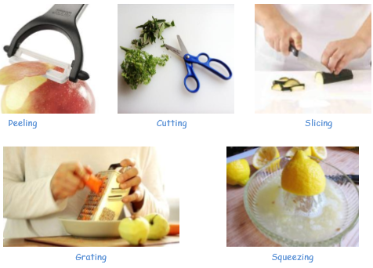

Hygiene – some key pointers

- Jewellery is removed
- Hair is tied back
- Sleeves are rolled up
- Aprons are on
- Hands are washed
- Cuts are covered with blue waterproof dressing

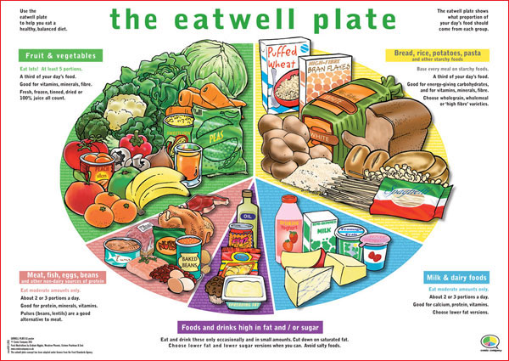
- Healthy Eating
The ‘eatwell’ plate shows the amount of each of the 5 different food types we should eat for a balanced diet.

- We need to eat lots of fruits and vegetables and bread, rice, potatoes, pasta and other starchy foods.
- We need to eat and drink some milk and dairy foods and meat, fish and eggs and other non-dairy proteins.
- We should eat and drink a small amount of food and drinks high in fat and sugar.

