Year 1 Mechanisms (sliders and levers)
Prior Learning: Early experiences of working with paper and card to make simple flaps and hinges. Experience of simple cutting, shaping and joining skills using scissors, glue, paper fasteners and masking tape.
Future learning: Further work with mechanisms in KS1 – wheels and axles. Work with levers and linkages in LKS2. Further develops knowledge of pivots (fixed and loose) and work with linkages which join two levers together.

Facts | Vocabulary
- What are sliders and levers?  Slider – a knob that is moved left-and-right or up-and-down to control something, such as the volume on a radio.  Lever – a solid bar resting on a pivot, used to move a heavy load with one end. | - Pivot – the central point that a lever rests on.  - Push – applying a force to move something away.  - Pull – applying a force to move something closer.
- What is a design?  A design is when you plan what something will look like and what it made out of before you start making it. The design will usually be based on the design criteria (what does your model need to do?). You will then design what it should be like before you make it. | 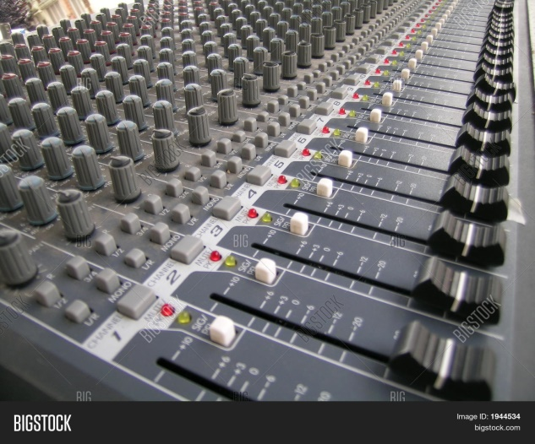  Real world sliders and levers.  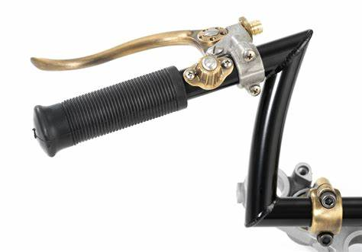  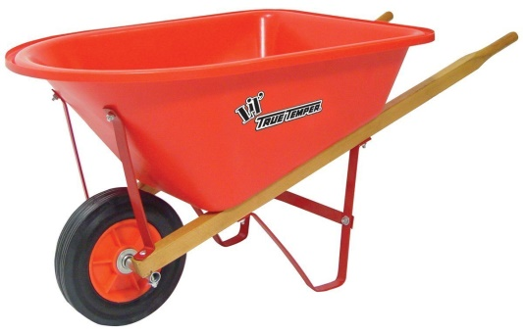
3. What is evaluating?

Once you have finished making your product, you must discuss how well it works in relation to the purpose and design criteria.
4. Sliders

5. Levers
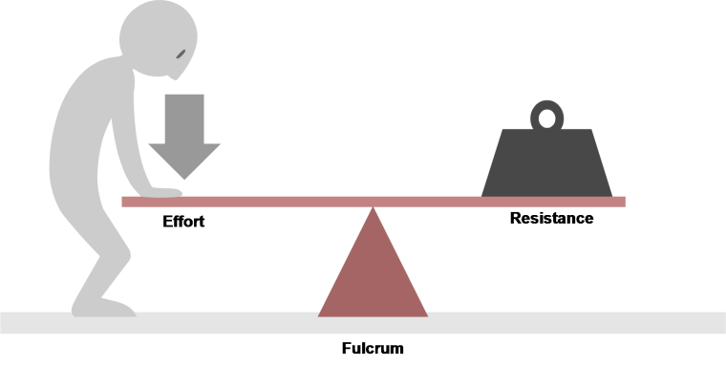

Youtube:

https://www.youtube.com/watch?v=n7dUtwejenQ – understanding levers.
https://youtu.be/lueqE0lxLyc

