Year 2- History – Ellen MacArthur
POS: The lives of significant individuals in the past who have contributed to national and international achievements
Prior content: Changes within living memory- Y1
Facts | Vocabulary
- Facts about Ellen MacArthur  - She was born 8th July 1976  - Her first sailing experience was on her Aunts boat when she was a child.  - She saved up her spending money to buy her first sailing boat aged 17  - Her first boat, an eight-foot dinghy she called Threp'ny Bit,  - 7th February 2005 she broke the world record for the first around the world sailing trip  - 2nd September 2010 retired from sailing | - Explorer- A person who explores a new area  - America- the 3rd largest country  - Asia- A continent  - Europe-A continent  - Sail- To travel in a boat  - Atlantic-A coast  - Voyage- A long journey involving travel by sea or space.  - Charity- An organisation to raise money for those in need  - Retired- Left one’s job  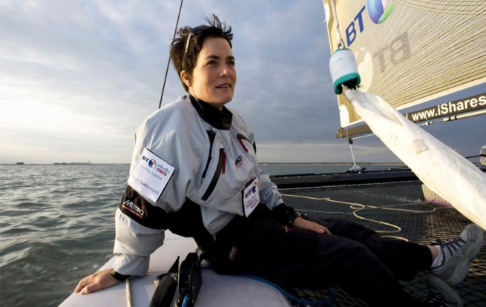  Ellen MacArthur
- Around the world

- In 2004, Ellen set off
- She sailed around the whole world on her own
- After 71 days, Ellen had sailed 26,000 miles and became the fastest person to sail around the world on their own.
- Impact on Britain  - Charities were set up in her name  - Ellen MacArthur cancer trust – Rebuilding children’s confidence  - Ellen MacArthur Foundation –Aim to eliminate waste on the environment | Voyages  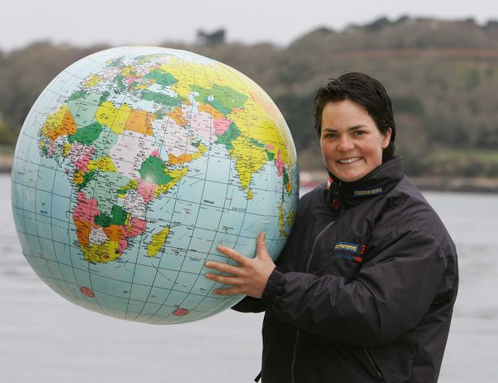  Ellen travelled around the world across the seven seas.
