Year 2- History – Great Fire of London
POS: Events beyond Living memory that are significant globally or nationally
Prior content: Changes within living memory- Y1
Facts | Vocabulary
- Events of the Fire  - 2nd September 1666 fire breaks out on Pudding Lane  - 3rd September-The fire spread near the tower of London  - 4th September- St Pauls Cathedral is destroyed  - 5th September- The fire burns more slowly  - 6th September- The fire is put out | - Bakery- Where bread and cakes are made  - London- The Capital city of England  - Diary- A book with pages for each day of the year to write about events that have happened  - Cart- A vehicle with 2 or 4 wheels pulled by a horse  - Flammable- Easily sets on fire  - Eye Witness- A person who has seen something and can give a description  - Embers- Small pieces of glowing coal or wood in a dying fire  - Monument- A structure that reminds us of a person or event  - Burn- In flames and on fire  - Possessions- Things that are owned.  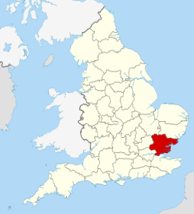  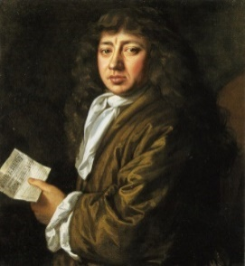  Samuel Pepys London
- Samuel Pepys
- Eye witness
Wrote a dairy of the events of the Great Fire of London
- Artefacts
- Water squirts- Similar to a water blaster filled with water
- Fire hooks- A pole with a hooked metal head used in firefighting for pulling down walls.
- Wattle and Daub- material of sticks and twigs covered in clay for building.
- Fire Mark- A metal plaque to show a building was insured
- What caused the Great fire and how did it spread?
- The houses were made of wattle and Daub
- The houses were built very close together and warehouses contained flammable materials
- A very strong wind blew the flames from house to house
- London was very dry after a hot summer

- London after the Great Fire  - Christopher Wren helps with the re-build of London  - It took approximately 50 years to re-build the city  - Building regulations act in 1667  - Limit to high floors and street width  - The introduction of fire hydrant systems and fire regulations leading to the fire brigade | Water squirt  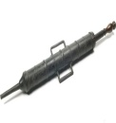  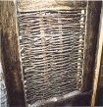  Wattle and Daub  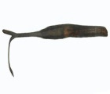  Fire Hook  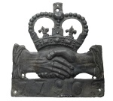  Fire Mark  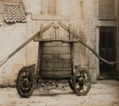  17th Century Fire Engine
Warrington links:

Staircase House- To retell the story of the ‘Great Fire’ in 17th Century rooms.

Warrington Fire station- Re-enacting the spread of the fire

Warrington Library- Records of fire brigade

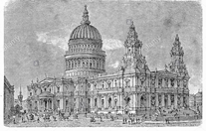
London links:
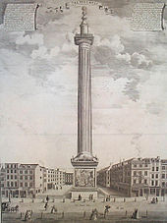

Wren Monument The re-build St Pauls Cathedral

