Year 2- History – Neil Armstrong
POS: The lives of significant individuals in the past who have contributed to national and international achievements
Prior content: Changes within living memory- Y1
Facts | Vocabulary
- Facts about Neil Armstrong  - Born 5th August 1930  - Lived in Ohio, in the USA  - He was an Astronaut and a military pilot  - He got his pilot’s license when he was 17  - At 17, Neil went to University to study aeronautical engineering – the science used in the designing and buildings of aircrafts  - He was the first human to land on the moon  - He died 25th August 2012 | - Explorer- A person who explores a new area  - Astronaut- A person who is trained to travel in a spacecraft  - Astronomy- the study of stars, planets and space  - NASA- National Aeronautics and Space Administration  - Mission- An important assignment given to a person or group of people.  - Regolith- materials such as dust, soil and broken rock covered in solid rock.  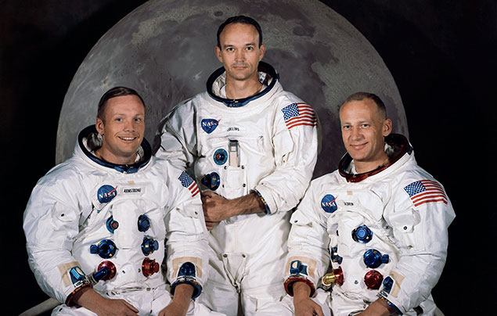  The Apollo 11 crew members  Neil Armstrong, Michael Collins and Edwin E. “Buzz” Aldrin
- Apollo 11 mission

- The mission was to ‘perform a manned lunar landing and return’.
- The Saturn V Rocket was the name of their space rocket
- Neil walked 60metres on the surface of the moon
- They collected dust materials to bring back to earth

- Impact on Britain  The understanding of the moon  - The lunar surface is solid  - The moon is covered in regolith  - The moon has a dust, mantle and core like the earth  Space travel  - More lunar landings were completed after this achievement | 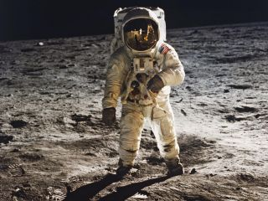  Moon Landing  ‘That’s one small step for man and a giant leap for mankind’
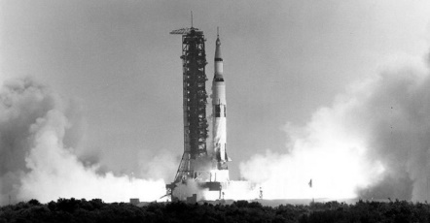
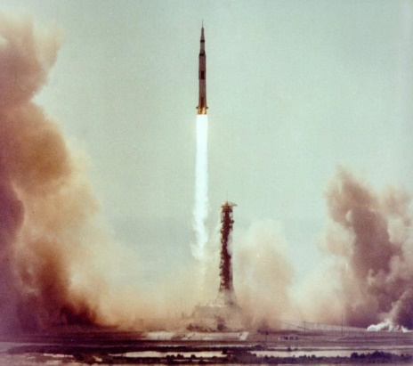

The Saturn V Rocket

