Y2 Textiles - Wax Resist
Prior Learning: mixing colours, lines, patterns, using water colours, identifying shapes.
Facts | Vocabulary
- Warm and cold colours:  - Warm colours - red, orange, yellow and variations of those three colours  - Cold colours - include green, blue, purple and the variations of those colours | - Warm  - Cold  - Cool  - Spectrum  - Variation  - Wax resist sticks  - Fabric  - Texture  - Fabric dye
- Wax Resist painting:
- A process in which you use two materials which resist or repel each other to create a piece of art
- Waterproof
- Often uses wax

- Using wax resist sticks:
- Resists paints and creates shimmering effect
- Creating patterns and lines
- Natural medium

- Using fabric dye:  - Used to add colour to fabrics  - When applied, creates a chemical bond  - Thin layers | 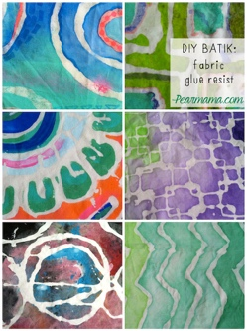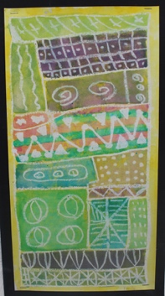  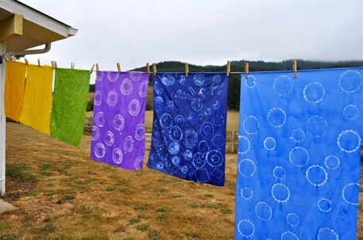  Wax Resist patterns  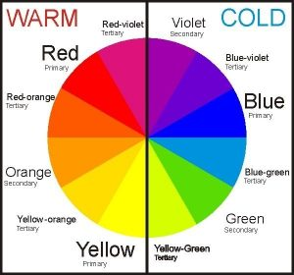  Warm and Cold colours
- Designing a pattern
- Warm colours – vivid and bold in nature
- Cold colours – calming or soothing in nature
- Lines – connecting two points
- Patterns – a repeated decorative design
- Shapes – different forms with outer edges
- Creating their design using wax sticks on fabric:
- Cotton – a soft, fluffy material
- Use wax paper underneath to protect the surface
- Uses a range of lines, pattern, colour and shape
- Using fabric dye on the designs:
- Warm and cold colours
- Thin layer
- Needs time to dry
- Evaluating:
- Texture – how something feels when it is touched
- Colour, line, pattern and shape
- The wider influences of:
- Other types of fabric art
- Other materials such as Vaseline and foil
- Famous artists
Wax resist on fabric technique: https://abeautifulmess.com/2013/03/wax-resist-technique-scarf-diy.html
How to dye fabric
https://www.youtube.com/watch?v=a7M61pYYlOk
Water colour wax resist
https://www.youtube.com/watch?v=CbLsLxvzp3M

