Year 2 Painting – Colour mixing
Prior Learning: primary colours, secondary colours, understanding of line, colour, pattern, texture and shape,
Facts | Vocabulary
- Painting is:  - The action or skill of using paint | - Painting  - Claude Monet  - Hues  - Tints  - Shades  - Tones  - Watercolours  - Wash  - Dry on dry  - Wet on wet  - Blotting  - Influenced by/ Inspired by
- Claude Monet:
- Born in France in 1840
- Liked to use watercolours to create landscapes and paintings of natural things

- Mixing colour:
- Tertiary colour – brown – mixing of three primary colours
- Primary and secondary colours can be mixed to create tints, shades and tones of the original hue (colour)

- Tints:  - Adding white to a colour to make lighter tints (pastel colours) | 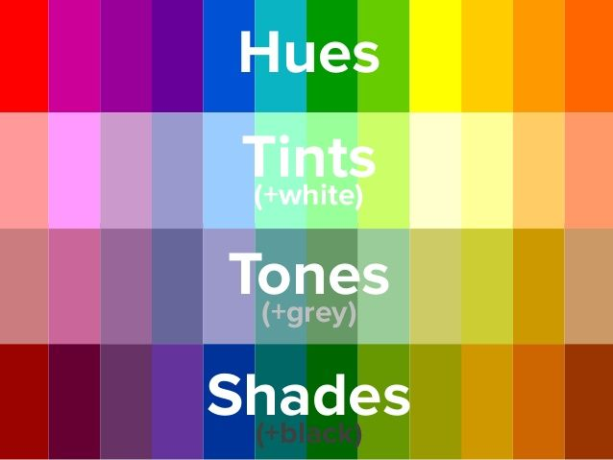  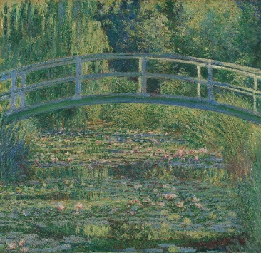  The Water-Lily Pond  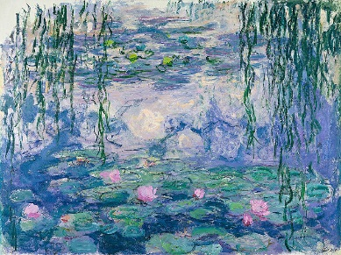  Waterlilies  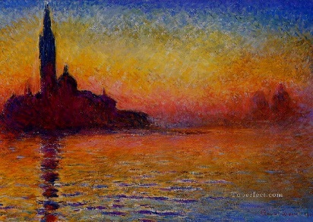  Venice Twilight
- Shades:
- Adding black to a colour to make darker shades

- Tones
- Adding black and white (grey) to make darker or lighter tone
- Watercolours:
- Creating a wash
- Dry on dry
- Dry on wet
- Wet on wet
- Blotting technique
- Creating our own patterns/artwork using Claude Monet’s artwork as inspiration:
- The Water Lily Pond
- Waterlilies
- Venice Twilight
- The wider influences of:

Youtube:
Claude Monet information:
https://www.tate.org.uk/art/artists/claude-monet-1652

https://www.claudemonetgallery.org/

Using watercolours:
https://www.youtube.com/watch?v=yl6V-gpkHOU

