Year 2 Sculpture
Prior Learning: understanding of colour, pattern, texture and shape, understanding of other artists, tints, tones, shades
Facts | Vocabulary
- Sculpture is:  - Making a 2D or 3D form by carving, casting or other shaping techniques | - Sculpture  - Andy Goldsworthy  - Land art  - Three-dimensional (3D)  - Two-dimensional (2D)  - Decay  - Weaving  - Nature/natural  - Local  - Influenced by/ Inspired by
- Andy Goldsworthy:
- Born in Cheshire, England in 1956
- Famous sculptor, photographer and environmentalist
- Enjoys creating land art situated in natural settings

- Work of Andy Goldsworthy:
- Colourful river
- 3D sculptures using natural resources
- Three-dimensional (3D) shapes have three measurements, such as length, width, and height
- Lots of his work was temporary as it decayed

- Materials:  - Natural materials – stones, sticks, leaves, bricks, rocks  - Texture – rough, hard, soft, smooth | 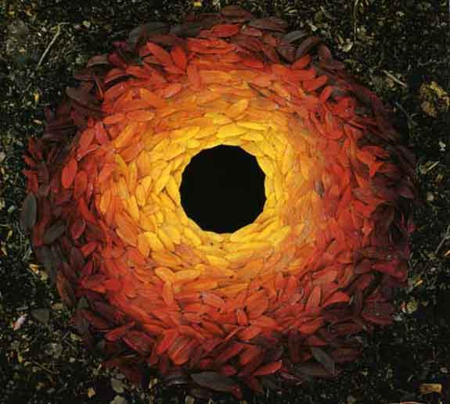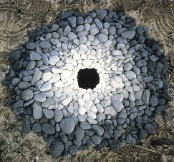  Art of Leaves Magical land art  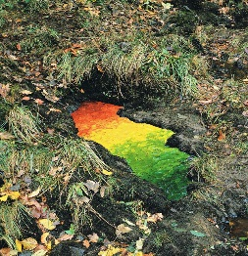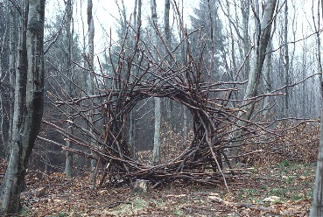  Colourful river Woven Branch Circular Arch  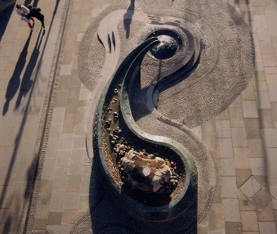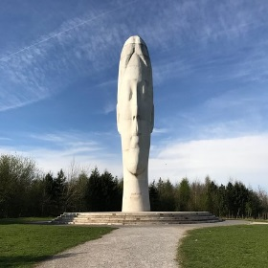  River of Life, Warrington Dream, St. Helens
- Colour change using:
- Tints – getting lighter by adding white
- Shades – getting darker by adding black
- Tones – getting darker/lighter-adding black & white (grey)

- Form of his designs:
- Circles – round 2D shapes
- Spirals – winding in a continuously widening curve
- Lines – connecting two points

- Weaving using branches and wool:
- Creating a Y-stick loom
- Weaving in and out

- Creating own sculptures based on work of Andy Goldsworthy:
- The Art of Leaves
- Magical Land Art
- Woven Branch Circular Arch

- The wider influences of:
- Local sculptures include the ‘River of Life’ in Warrington and ‘Dream’ located in St. Helens
- The River of Life project was developed in the aftermath of the 1993 IRA bomb in Warrington
Youtube:
Andy Goldsworthy information:
https://www.tate.org.uk/art/artists/andy-goldsworthy-7274
https://www.creativityfuse.com/2010/10/andy-goldsworthy-sublime-and-beautiful-environmental-art/
Creating a Y-stick loom
https://www.youtube.com/watch?v=u9lUuNK2HyI
Branch weaving
https://www.youtube.com/watch?v=zvsSFEmVU6A

