Year 3 Drawing – Sketching movement
Prior Learning: understanding of line, colour, pattern, texture, shape, materials, techniques of: linear, side stroke, scumbling and feathering, shadow, use of different pencils
Facts | Vocabulary
- L.S. Lowry:  - Born in Stretford, Manchester in 1887  - Landscape paintings – areas around the North-West  - Also included people (matchstick men) and portraits | - Designer  - L. S. Lowry  - HB  - Oil pastels  - Blending – heavy pressure/light pressure  - Pointillism  - Scumbling  - Pressure blend  - Sgaffito  - Movement  Influenced by/ Inspired by
- Exploring his work:
- On the Promenade
- Coming out of School
- Punch and Judy
- Using different pencils to show light to dark:  - 9H – HB (H leads are lighter)  - B stands for Bold; H stands for Hard  - H leads are extremely smudge-resistant and give cleaner lines  - Useful for things such as outlines, technical drawings, light sketches, and even watercolors | 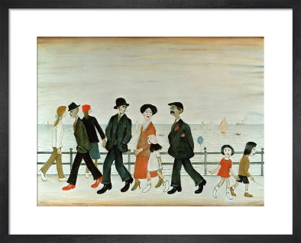  On the Promenade  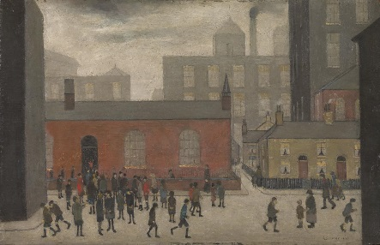  Coming out of School  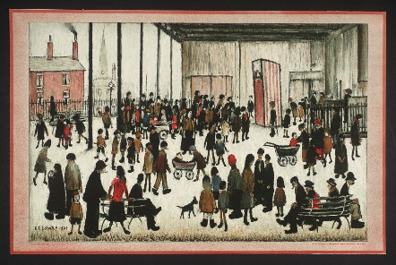  Punch and Judy
- Oil pastel techniques (see video)
- Colour mixing – with white/grey/black
- Blending – heavy pressure and light pressure
- Pointillism – using tiny dots of pure colour
- Scumbling – softening and blending by going over the top with lines
- Pressure blend (smudging) – smearing by rubbing
- Sgraffito – putting down one layer, covering with another, then scratching to reveal a pattern

- Creating movements using colours and shapes:
- Single lines and flowing motion to create action
- Shading can create 3D image
- Lowry achieved this with his matchstick men

- Creating our matchstick people using L. S. Lowry as inspiration:
- On the Promenade
- Coming out of School
- Punch and Judy

- The wider influences of:

Youtube:
L. S. Lowry information:
https://www.tate.org.uk/art/artists/l-s-lowry-1533

10 oil pastel techniques
https://www.youtube.com/watch?v=jm6wo-8rJD0
Grading of pencils:
https://www.jetpens.com/blog/the-best-lead-grade-for-every-application/pt/475

