Year 3- History- Early Civilisations
POS: Children should be taught about the earliest civilisations- where and when the civilisations appeared
Prior content: Pre-historic Britain from Stone Age to Iron Age
Overview of 4 Earliest civilisations | Vocabulary
Indus Valley  - The Harappa culture thrived in the Indus River Valley which is now modern Pakistan  - They built sophisticated cities- Mohenjo-Daro was the biggest city with 40,000 people living there  - They invented sewerage systems  - People would build houses and cities close to the river so they had access to the water for cooking, drinking and cleaning.  - Urban town planning- Mahenjo Daro  - long distance trade with settlements in Mesopotamia  - Trade goods include terracotta pots, beads, gold, silver, gems, metals, seashells and pear | - Agriculture- The practice of farming, growing crops and rearing animals  - Civilisation- The society, culture and way of life of a particular area  - Traders- A person who buys and sells goods  - Architecture- Designing and constructing buildings  - Craftsman- A worker skilled in a particular craft  - Valley- A low area of land between hills and mountains-  - Excavation- digging something up in an archaeological site  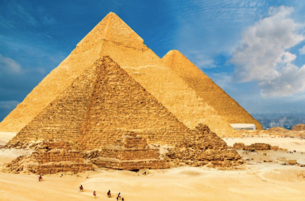  Ancient Egypt  Great Pyramids of Giza  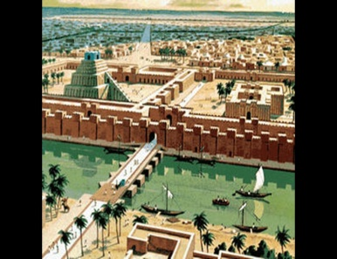  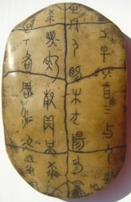  Shang Dynasty Ancient Sumer  Oracle Bone Mesopotamia  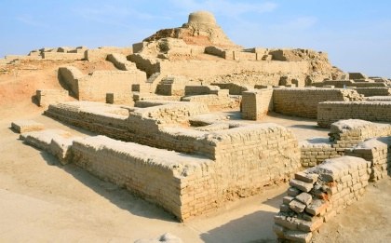  Indus valley  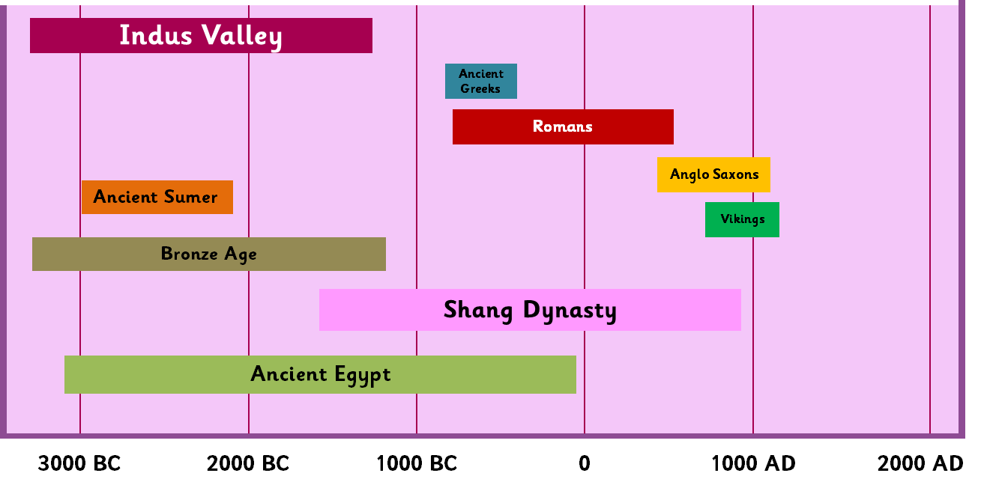  Mahenjo Daro
Ancient Egypt
- Egyptian pyramids were built as tombs for Pharaohs
- Over 130 pyramids have been discovered
- Great pyramid of Giza was the largest pyramid
- The river Nile provided fertile black silt that allowed agriculture to flourish.
- The Egyptians preserved a dead person’s life through a process called mummification.
- The Egyptian alphabet contained more than 700 hieroglyphics
- The Egyptians invented pens, paper, locks, keys and toothpaste!

Ancient Sumer:
- The Sumerians built large cities along the river banks of the Euphrates and Tigris rivers.
- The area was known as ‘Mesopotamia’, meaning ‘between 2 rivers’.
- They were the first inventors of the wheel, mathematics, time and sailboats.
- They achieved a total of 39 ‘firsts’.
- Today, Sumer no longer exists
- The area today is known as Southern Iraq.

Shang Dynasty – Ancient China
- Established 1760 BC the same time as the Bronze Age.
- In China, based around the Yellow River.
- An agricultural society who’s tradesmen had skills in bronze and jade work.
- The first Chinese dynasty to develop a form of writing using pictograms.
- Oracle bones were discovered and used when asking the Gods for help.
- They invented chop sticks, the calendar, glazed pottery and the chariot.
- They used bronze weapons including spears, arrows, daggers and swords.
- Horse-drawn chariots where their tanks

