Year 3 – Printing – Cave art
Prior Learning: texture, sketching, printing with a range of materials, warm/cold colours, line, pattern, colour, shape.
Facts | Vocabulary
- Parietal Art:  - Archaeological term for artwork done on cave walls or large blocks of stone.  - Can also be known as ‘Cave Art’.  - Refers to carvings, paintings and drawings. | - Cave art  - Parietal  - Pre-historic  - Lascaux  - Culture  - Wealth  - Convey  - Charcoal  - Vine and pressed  - Bumpy  - Tool  - Soft pastels.
- Cave Art:
- Type of Parietal Art
- Found on walls or ceilings of caves
- Usually implies pre-historic origin
- Influence on culture, creativity and wealth:
- Oldest paintings predate 28,000 years ago.
- Tells a story
- We can learn a lot from the past.
- Examining Lascaux Cave Art:  - A complex of caves in Southwestern France.  - Estimated to be up to 20,000 years old.  - Paintings consist primarily of animals | 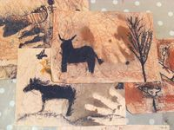  Example cave art  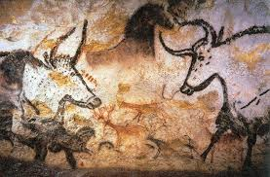  Lascaux Cave  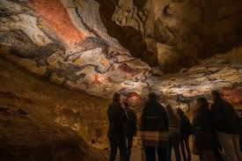  Lascaux Cave
- Using charcoal:
- Different types including vine charcoal and pressed charcoal
- Pressed charcoal is much darker
- Shading and blending to create tones
- A natural material
- Creating and printing with own printing tool:
- Drawing a backwards template onto potato
- Print onto different textures
- Creating patterns and shapes
- Creating own Cave Art painting:
- Create a rough surface using sand
- Realistic
- Soft pastels and charcoal
- Printing on a rough texture
- Tell a story in history
- Evaluate the finished work by comparing with original cave art
- The wider influences of:
- The Stone Age
- Pre-historic events
- Importance of cave paintings on the culture, wealth and creativity of the nation.

All about Cave Art
https://www.youtube.com/watch?v=ZjejoT1gFOc
Virtual Tour of Lascaux caves
https://vimeo.com/40849516
How to recreate a cave painting
https://www.youtube.com/watch?v=BM2C3jLCjNM
Printing using a potato
https://www.bbc.com/teach/class-clips-video/art-and-design-ks1-ks2-printmaking-with-different-materials/zhytscw

