Year 3- History- Stone Age to Iron Age
POS: Children should be taught about the changes in Britain from the Stone Age to the Iron Age
Prior content: Changes in living and non-living memory
Significant events
Facts | Vocabulary
- Stone Age - It was a large period of time that went over 100,000 years  - During the stone age there were 4 ice-ages  - There were three periods during the Stone Age :  Palaeolithic- The old stone Age  Mesolithic- The Middle Stone Age  Neolithic- The New Stone Age  - Hunter gatherers- prehistoric nomadic groups that hunting for food  - Life progressed in each period with developments in  homes, tools, clothes and food  - Affected Britain’s landscape. Focus on  Stone circles- monument of a circular/oval arrangement  Henge-circular or oval-shaped bank with an internal ditch surrounding a central flat area  Barrows- a hemispherical mound of earth and/or stone raised over a burial placed in the middle.  - Archaeological evidence was found to support our learning such as Hand Axe and Bone Needles.  - Skara Brae- Scotland Stone Age Village  - Stonehenge- England- Circle of tone built in the stone age | - Archaeologist- Person who learns about the past by digging up artefacts and studying them.  - Artefact- An object made by a human being  - Site- An area of ground where a town, building or monument is  - Preserve- To keep something in good condition  - Tribes- A group of people that live together for protection  - Flint- A type of stone that can be shaped into blades, knives and spears for hunting  - Settlement- A place where a group of people live together in many buildings  - Agriculture- The practice of farming and growing crops  - Era/Period- A length of time covering many years  - Hill Fort- a settlement surrounded by wall or ditches  - Prehistoric- The period before written records  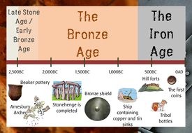  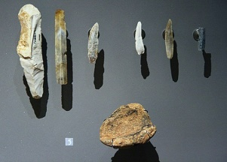  Stone Age  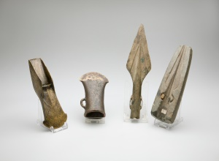  Bronze Age  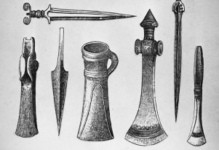  Iron Age
- Bronze Age – This followed the Stone Age
- The Bronze Age started when metals began to be used. Copper and tin were mixed together to make a stronger material for tools and weapons.
- Humans started to work with metal to make tools such spears, daggers, swords and axes.
- Bronze was used to make weapons, farming tools and jewellery
- Trade links developed through the use of boats
- Stonehenge-
- Iron Age – Followed the Bronze Age
- Changes in houses and settlements
- People lived in protected hill forts due to the developments of building tools and materials
- Land was farmed, which reduced the need for hunter gathers.
- Trade links were established.
Text-
Stone Age Boy
A Street through Time
Visits:
Beaston Castle- Iron Age workshop
Beaston Castle- Bronze Age House
Links to Warrington-
Rivers and settlements

