Year 3 – Textiles - Sewing
Prior Learning: materials,
Facts | Vocabulary
- Textiles are:  - Are often made by weaving and knitting materials and fibres together | - Textiles  - Sewing  - Stitches  - Binca  - Running stitch  - Cross stitch  - Design/pattern  - Needle  - Evaluate  - Influenced by/ Inspired by
- Sewing is:
- The craft of fastening or attaching objects using stiches made with a needle and thread
- Exploring stitches:
- Threading a needle – putting thread onto a needle
- Running stitch – small even stitches which run back and forth through fabric without overlapping
- Cross stitch – a stitch formed by crossing two stitches over each other

- Using Binca:  - Fabric with holes in – used for cross stitch | 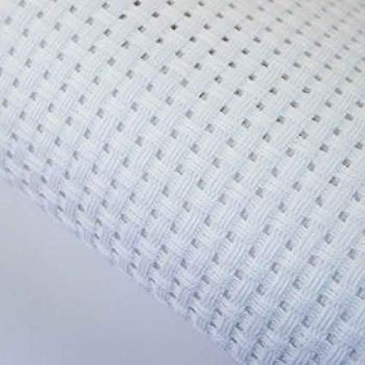  Binca  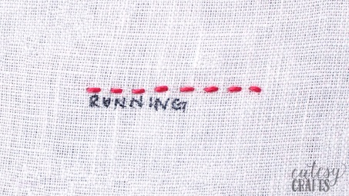  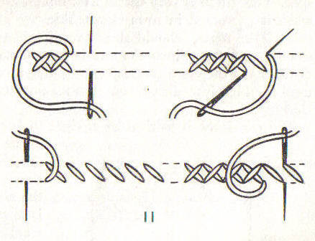
- Creating patterns using different stitches (bookmark):
- Running stitch
- Cross stitch

- Designing a pattern to be used on a card:
- Sketch design
- Label materials
- Identify the stiches used

- Creating the design:
- Thread the needle
- Follow the pattern
- Stick it in the card
- Evaluate the finished work by comparing with design

- The wider influences of:

Youtube:
Threading a needle:
https://www.youtube.com/watch?v=wYBo1luO74U
Running stitch:
https://www.youtube.com/watch?v=W4nhj8kMpAI
Cross stitch:
https://www.youtube.com/watch?v=OLYdbatulwM
https://www.youtube.com/watch?v=TYWxwveP8LU

