Year 4- History- Ancient Greece
POS: Children should be taught about Ancient Greece – a study of Greek life and achievements and their influence on the western world
Prior content: Pre-historic Britain from Stone Age to Iron Age
Facts | Vocabulary
- Ancient Greece 800BC- 146BC  - Became part of the Roman Empire in 146 BC | - Acropolis- A fortified citadel within a larger city  - Assembly- In Athens, the assembly is consisted of the group who came to vote  - Democracy- A form of governance where citizens have a say in how they are ruled  - Oligarchy- A type of government where power is held by a few people  - Olympics- An athletic event held by the ancient Greeks every 4 years  - Titans- The first Greek Gods  - Tyrant- The Ruler of a Greek city state like King  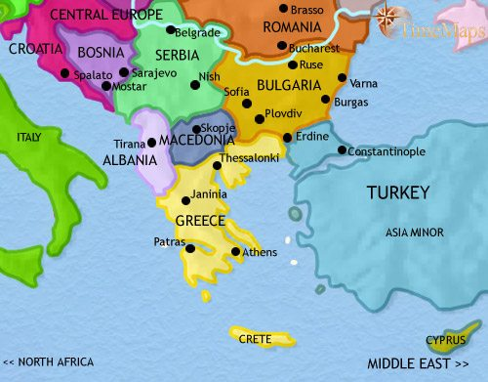  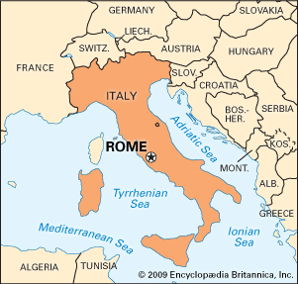  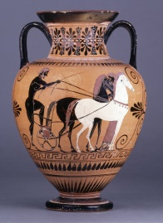  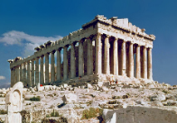  The Parthenon Greek pottery  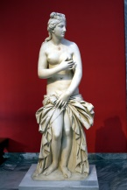  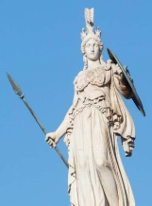  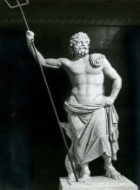  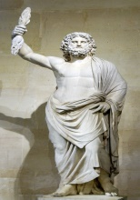  Zeus Poseidon Athena Aphrodite  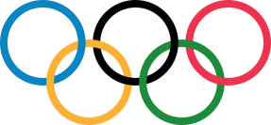  Olympics
Social Hierarchy
- Upper class
- Middle Class ( Metics)
- Lower Class- (Freedmen)
- Slave Class
City-States
- Athens- It is the birth place of democracy and the heart of the Ancient Greek civilization. Named after the Greek Goddess Athena.
- Sparta- Sparta is well-known for its military strength. It had a very strong army, because Spartan boys trained to become warriors from the time they were 7 years old.
Governance took different forms
- Monarchy
- Oligarchy
- Democracy
- Tyranny
Gods and Goddesses
- Zeus was the wisest and most important of all the gods. He was God of the Earth and the
- Poseidon- Second most powerful God
- Athena- Goddess of Wisdom
- Aphrodite- Goddess of love and beauty

The Parthenon is a temple in Athens that was built to honour the goddess Athena. It took around 15 years to build!
Religion
The Greeks believed in Gods and Goddesses
Pottery
Ancient Greek pottery was decorated with scenes of soldiers, gods or daily life, as well as geometric patterns.
Architecture
The Ancient Greeks built many impressive buildings, including temples, theatres and palaces.
Mythology
Greek myths are stories that include magic and creatures, as well as the Greek gods and goddesses. There is usually a message at the end of the story. The myths were often stories of good versus evil, with characters facing difficult obstacles.
Olympic games
Olympic Games, which began in Greece in 776 BC as a religious festival dedicated to Zeus, took place every four years

