Year 4 – Mosaic and Collage
Prior Learning: collages, cutting and sticking, creating patterns, warm and cold colours, texture, primary colours.
Facts | Vocabulary
- What is an architect?  - A person who designs buildings | - Architect  - Antoni Gaudi  - Mosaic  - Decorative  - Interior  - Tesserae  - Park Guell  - Composition  - Stained Glass Windows  - Wax paper
- Antoni Gaudi
- Born in 1852 in Spain
- Spanish architect
- Most of his work is located in Barcelona
- What are mosaics?
- A piece of art or image made from small pieces of coloured glass, stone or other materials.
- Used as decorative art or interior decoration
- Often made of small, roughly square, pieces of stone or glass of different colours, known as tesserae.
- Examining the work of Antoni Gaudi  - The Boulevard of Broken Tiles  - Park Guell  - Stained glass windows | 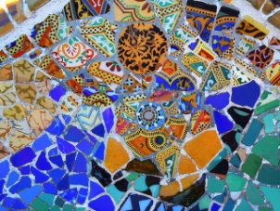  The Boulevard of Broken Tiles  Park Guell  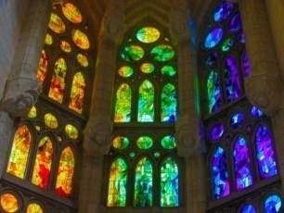  Stained Glass Windows  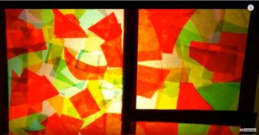  Stained Glass Window example
- Creating patterns and experimenting with colour and shape
- Mixing and blending
- Cutting and sticking
- Shapes and sizes
- Creating own mosaic animals
- Small chunks
- Rearranging paper to focus on colour and composition
- Texture
- Examining Gaudi’s stained glass windows
- Sagrada Familia
- Only used the primary colours and white
- Made from glass
- Making patterns/mosaics with tissue paper
- Cutting shapes
- Cutting and sticking using primary colours
- Creating own stained glass window
- Create a frame using card and wax paper
- Cut tissue paper into different shapes and sizes
- Overlapping technique to create patterns
- The wider influences of:
- Use of other materials – tiles, glass, etc.
Work of Gaudi
https://www.bbc.com/bitesize/clips/zgrkq6f
All about Gaudi
http://primaryfacts.com/2743/antoni-gaudi-facts-and-information/
Gaudi and Barcelona
https://www.youtube.com/watch?v=vHOPdddnLCc
Park Guell
https://www.youtube.com/watch?v=HP_bOvoUr90
Sagrada Familia – how Gaudi created stained glass windows
https://blog.sagradafamilia.org/en/divulgation/stained-glass-windows-how-they-were-created/
How to create Stained Glass Windows for beginners
https://www.youtube.com/watch?time_continue=35&v=kHax38AtEuI

