Year 4- History- Romans
POS: Children should be taught about the earliest civilisations- where and when the civilisations appeared
Prior content: Pre-historic Britain from Stone Age to Iron Age
Facts | Vocabulary
Prior settlements and civilisations  - Stone Age , Bronze Age, Iron Age  - Indus Valley  - Ancient Egypt  - Ancient Sumer  - Shang Dynasty | - Chiefs- Leader, Ruler or King  - Conquer- Take control of another land  - Emperor- Leader or king of an empire  - Invasion- When a foreign army enters the country by force  - Monarch- An emperor, king or queen  - Empire- A group of countries rules by one monarch  - Army- An organised military force  - Legacy- Something left behind  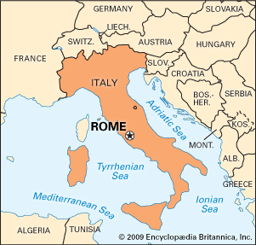  305AD  117AD  133BC  237BC  800BC
Romans
- Romans had started spreading their influence 800BC
- People who lived in Britain between 750BC and 12BC called Celts
- The Roman Empire only started around 27BC.
- They tried to invade Britain in 55AD but failed
- In 43AD when they actually conquered Britain.
Push and Pull factors
- The push is the expansion of empire.
- The pull is the Romans wanted the resources that could be found in Britain – tin, gold, silver, clay, livestock and people. Focus on metals as goods for Romans to acquire when they invade
Julius Ceasar and Claudius Invasions
- Caesar was not successful and it was nearly 100 years before the Romans did invade.
- Caesar returned in 54 BC but retreated again
- After Julius Caesar was killed the next 3 emperors did not try to invade Britain
- When Claudius became emperor, he was prepared well for the invasion.
- 41AD Claudius invaded Britain
- People and their land belonged to Rome
Impact in Britain
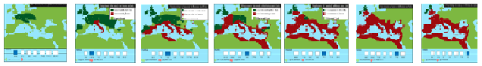
- Good straight roads were needed to connect all parts of their empire and linking their towns.
79AD
- The Romans needed an easy way to travel so they built roads to replace the muddy tracks.
- Roman Law- Legal systems
Spread of the Roman Empire
44BC
- Religion - The Romans banned Christianity
Impact on Warrington
- Warrington is at a crossroads it stands at the centre of a chain of networks
- Roman Wildespool became a major industrial and supply centre.
- The M6 crossed the M56 and M62. These match the pattern established by the Iron Age
- Manchester was a fort built between Chester and York to protect important roads. The fort was built in AD79 guarded on one side by the rivers Medlock and Irwell. It was named Mamucium.
Additional resources
https://www.history.org.uk/podcasts/categories/431/podcast/5/roman-britain PODCAST about life in Roman Britain

