Year 4 – Sculpture – Greek life
Prior Learning: Shape, pattern, colour, design, form, sculpture, 3D.
Facts | Vocabulary
- What is Pottery?  - Pots, dishes and other objects made of fired clay.  - Often made by a potter. | - Pottery  - Clay  - Otto and Vivika Heino  - Ancient Greek  - Vase  - Attic Clay  - Coiling  - Pinching  - Decoration.
- Who were Otto and Vivika Heino?
- Otto was born in 1915 in East Hampton, USA.
- Vivika was born in 1910 in New York, USA.
- They were artists working in Ceramics.
- Ancient Greek Pottery
- Holds a record of Ancient Greece
- Had many uses such as for food and perfumes
- Made from 1000 to 400 BC
- Examining Ancient Greek Pottery  - Made of Attic Clay  - Images of people  - Rounded shapes | 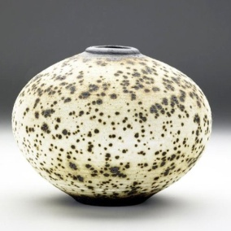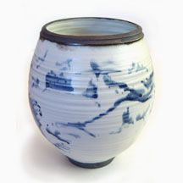  Ceramic 1 Ceramic 2  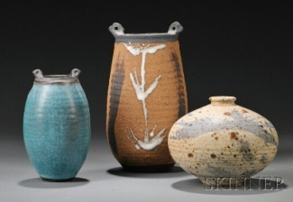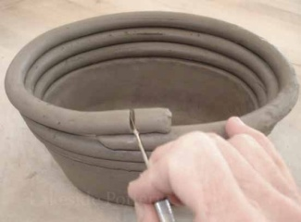  Ceramic 3 Coil technique  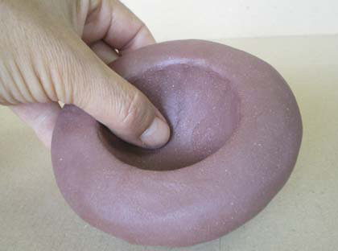  Pinch technique  Ancient Greek pottery:  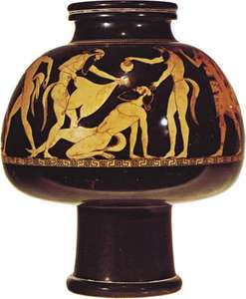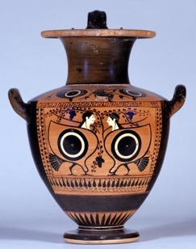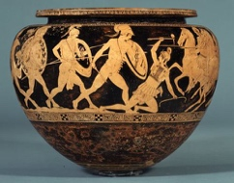
- Coil technique
- Method of creating pottery
- Roll it carefully until it creates a long roll
- By placing one coil on top of the other, different shapes can be formed.
- Pinch technique
- Used to create pottery that is functional
- Knead the clay to get rid of any air
- Consists of pinching and turning thumb movements
- Creating own ceramic to show the life of the Ancient Greeks
- Coil technique
- Pinch technique
- Purpose/use of the ceramic
- Painting and decorating
- Acrylic paint – fast drying, water resistant when dry
- Range of different brush types – thick and thin
- Patterns and designs
- Evaluating
- Similarities – things that are the same
- Differences – things that are different
- The wider influences of:
- History of ceramics – Romans, Egyptians, Mayans
- Clay or pottery building techniques
- How ceramics may be used in different cultures
- Importance of decoration
Ancient Greek pottery
https://www.youtube.com/watch?v=0GJsUfXQWSU

Coiling technique
https://www.youtube.com/watch?v=o8FmgUQtLHk

Pinching technique
https://www.youtube.com/watch?v=2CQAdMxjBik

Painting clay using acrylic paint
https://www.youtube.com/watch?v=ngPvBLb-PEA

