Year 4 RE – Christians God
Curriculum Aims: How and why might Christians use the Bible?
This unit investigates how and why Christians use the Bible today and why the Bible is seen as a source of inspirations and authority by many Christians. Pupils should understand that the Bible I not one book but a collection of books, written by different people at different times. They should know that the Bible contains two
main sections – the Old Testament (which is the Jewish scriptures) and the New Testament (about Jesus and the early Church). Pupils should explore the idea that the Bible has authority for Christians because it is ‘the Word of
God’, but that Christians have different views about what this means – some take it as a literal truth, whereas
others take the liberal view that it contains truths about God and how God wants people to live but that the stories themselves may not be literally true.
Pupils should be able to recognise and use specialist terms such as Gospel, parable, literal and liberal. They should also develop their skills in reading and interpreting religious texts.
Pupils should also learn about other sources of wisdom and authority that may guide Christians in making moral decisions.
Prior Learning: The importance and influence of the Prophets in the Bible as lessons for Christians to follow.

Facts | Vocabulary
- Beliefs & Values  - Explore different Christian beliefs about the Bible as the word of God  - Explain why the Bible can be described as a library and give examples of the different types of writings found in the Bible  - Describe why some Christians might view the Bible as an important source of authority and moral guidance | Bible, guidance, authority, moral, church leaders, prayer, conscience, Old & New Testament, Jewish scripture, Psalm, Proverb,
- Living religious traditions
- Explain why Christians might have different views about how to interpret and apply the Bible
- Explain why Christians might also look to other sources of authority when making decisions about how to live (eg. church leaders, prayer, conscience)
- Shared human experiences  - Discuss why people might have different views about what is right and wrong – and where these views might come from  - Describe the different sources of authority that humans might look to when making decisions about how to live their lives | 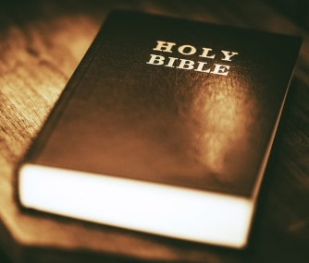  The Bible
- Search for personal meaning
- Reflect on their own understanding of morality and where it comes from
- Raise questions and discuss responses to different ideas about how to live well
Links : Explore how Christians might use the Bible. This clip might be a good introduction https://www.youtube.com/watch?v=tvGTbVP_jlA&index=28&list=PLcvEcrsF_9zJxDHG9JtcC miAgwVFRW3uK

Texts:
Compare different Bibles – a children’s Bible, a comic-book Bible, a Gideon’s Bible, an adult Bible.

Enrichment:

