Year 5- Anglo-Saxons
POS: Pupils should be taught about the Viking and Anglo-Saxon struggle for the Kingdom of England to the time of Edward the Confessor
Prior content: When the Romans left Britain, it became open to invasion. Link to Y4 Romans and Y5 Vikings
Who were the Anglo-Saxons?  - Anglo Axon Age from AD 410-1066  - Tribes from Germany, Denmark and the Netherlands  - There were 3 tribes, the Angles, the Saxons and the Jutes.  - The Angles settled in Northern England and East Anglia  - The Saxons settled in Southern England. | Key Vocabulary  - Burh- A well defended Saxon town  - Hoard- Items buried and left  - Interpretation- One person’s view of an event in history  - Invasion- Attacking and conquering another country  - Martyr- Someone who dies for what they believe in  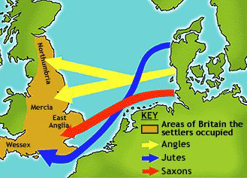  Anglo-Saxon Routes  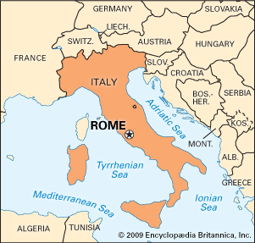  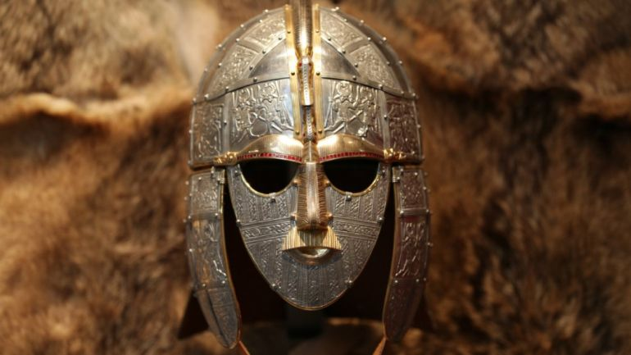  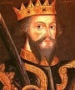  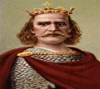  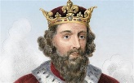  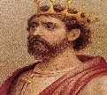  Edward the Confessor  Harold Godwinson  Edward the Elder  Alfred the Great  Anglo-Saxon Warrior
Kingdoms
- East Anglia- A small independent kingdom of the Angles, which was formed in the 6th Century in the wake of the Anglo-Saxon settlement of Great Britain. It was incorporated into the Kingdom of England in 918.
- Mercia was a large Anglo-Saxon kingdom that was centred around the River Trent. For 300 years (between 600 and 900AD) Mercia dominated England south of the River Humber – a period known as the Mercian Supremacy.
- Wessex was an Anglo-Saxon kingdom in the south of the country. A number of famous Wessex kings have become prominent figures in history, including Alfred the Great and Egbert – the first King of England.
- Northumbria was another medieval Anglican kingdom. It was originally made up of two separate kingdoms – Bernicia (from around Cumbria) and Deira (from around York) – until the two united around the year 654.
Danelaw
King Alfred the Great defeated the Vikings in 878 AD, and had them sign a treaty, which governed that the Vikings stick to their own land in north and east England this section of land became known as the Danelaw.
Battles
- Battle of Eddington- An Anglo-Saxon army led by King Alfred the Great defeated the Great Heathen Army, a collection of Viking warriors led by Guthrum.
- Battle of Stamford Bridge- This battle took place in the village of Stamford Bridge, in the east riding of Yorkshire. King Harold of England defeated a Viking army led by Harald Hardrada
- Battle of Hastings- 3 weeks after the Battle of Stamford Bridge, King Harold was killed by the Normans at the Battle of Hastings. William of Normandy became the first Norman King.
Key people
- Alfred the Great 849-899AD- Anglo-Saxon King of Wessex, who was famous for his victories against the Vikings.
- Edward the Elder- 877-924 AD. He was the son of Alfred the Great. He was the King of Wessex from 899 until his death in 924.
- Harold Godwinson. He was the last crowned Anglo-Saxon King of England.
- Edwards the Confessor- 1003-1066. He was one of the last Anglo-Saxon Kings of England. Failure to leave an heir behind led to the Norman invasion of England in 1066.

