Year 5 - Printing
Prior Learning: mixing colour, block printing, printing on different textures, printing with different materials, water colours, pattern, lines, colour, shape.
Facts | Vocabulary
- Who was Jean Michel Basquiat?  - Born in Brooklyn, New York on 22nd December 1960  - Neo-Expressionist painter  - His work was often inspired by his Puerto Rican heritage | - Jean Michel Basquiat  - Neo-Expressionist  - Self-taught  - Graffiti  - Street-art  - Mono-printing  - Pointillism printing  - Symbols
- Examining his artwork
- Untitled
- In Italian
- Dustheads
- What is Neo-Expressionism art?
- Emerged in the late 1970s
- A style of late modernist painting and sculpture
- Characterised by intense subjectivity and rough handling of materials
- What is Graffiti/street art?  - Visual art created in public places  - Can be viewed as an act of vandalism  - Often conveys important or personal messages | 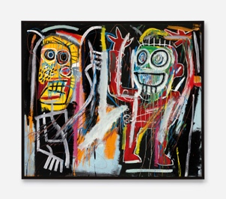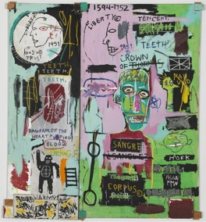  Dustheads In Italian  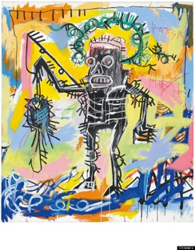  Untitled  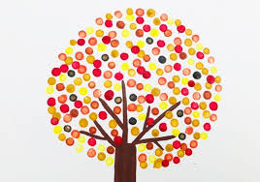  Pointillism printing  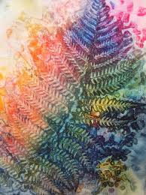  Mono printing
- Monoprinting
- A form of print making that has lines of images that can only be made once
- Makes an expression on paper where only one print can be made
- Techniques include potato printing and screen printing
- Pointillism printing
- Often used to create symbols or words
- Small, colourful dots
- Creating own painting inspired by Jean Michel Basquiat
- Mono printing to create background
- Block printing to create shapes and lines
- Pointillism to create symbols or lines
- Warm, cold and complimentary colours
- Evaluating artwork
- Similarities – things that are the same
- Differences – things that are different
- The wider influences of:
- Other Graffiti artists such as Banksy
- Impact on the wealth, culture and creativity of the nation, specifically New York
Youtube:

The story of Jean-Michel Basquiat
https://www.youtube.com/watch?v=zM4rGNLt2xY
https://www.youtube.com/watch?v=JX02QQXfb_o
http://basquiat.com
Neo-Expressionism:
https://www.tate.org.uk/art/art-terms/n/neo-expressionism
Mono printing:
https://www.youtube.com/watch?v=xOMWjWLAypQ
Pointillism printing:
https://www.youtube.com/watch?v=GUw78GAbLtc

