Year 5 – Sculpture – Clay tile
Prior Learning: printing, sketching, painting, colour, shape, lines, form, sculpture, 3D.
Facts | Vocabulary
- Who was Henri Rousseau?  - Born in 1844 in France  - Post-Impressionist Painter  - Inspired by the jungle and often painted nature and animals | - Ceramic  - Slab  - Measure  - Waterproof  - Decoration.  - Henri Rousseau  - Raised  - Indenting  - PVA
- Examining his artwork
- Tiger in a Tropical Storm
- The Snake Charmer
- Exotic Landscape
- Sketching and painting a nature setting
- B and H pencils (Bold and Hard)
- Observational sketching
- Mixing colours and creating tones with water colour
- What are ceramics?  - Made by taking mixtures of clay, powders and water and shading them into desired, 3D forms.  - Often for decoration | 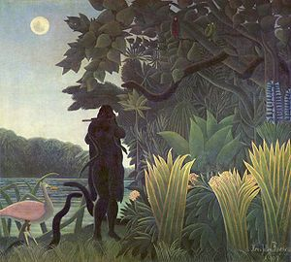  The Snake Charmer  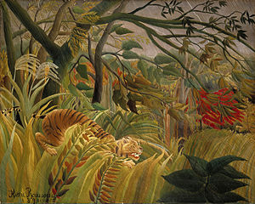  Tiger in a Tropical Storm  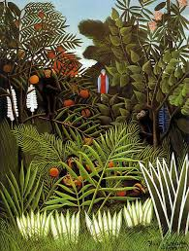  Exotic Landscape
- Creating a clay tile
- Flatten the clay to create a flat slab
- Desired thickness should be 1-1.5cm
- Measure out desired size, mark the outline and cut out using a knife.
- Decorating a clay tile using Henri Rousseau as Inspiration
- Poster paint
- Set using PVA to enable it to become waterproof
- Smooth brush strokes and bright, bold colours
- Creating a 3D, textured tile
- Indenting with objects
- Printing to create a desired texture
- Similarities and differences between flat and raised tiles
- Painting using thick and thin brushes
- Evaluating artwork
- Similarities – things that are the same
- Differences – things that are different
- The wider influences of:
- Spanish ceramic tiles
- Ceramic decoration
- Uses of ceramics.
All about Henri Rousseau
https://artistinschool.com/henri-rousseau/
How to make a clay tile:
https://www.doityourself.com/stry/how-to-make-ceramic-tile
Clay for Children
https://www.youtube.com/watch?time_continue=707&v=RIAfe1yG6ow
https://artfulparent.com/create-colorful-clay-relief-tiles-for-kids-with-air-drying-clay/

