Year 5 – Sketching – 3D perspective
Prior Learning: Lines, sketching, form, shape, patterns, colour, 3d perspective, observational drawing, landscape paintings.
Facts | Vocabulary
- Who is Paul Kenton?  - Born in Derby, England, in the 1960s.  - UK based artist famous for cityscapes  - Mainly uses water colours | - Paul Kenton  - Cityscape  - Perspective  - Horizon line  - Vanishing point  - Exhibit  - Realism  - Foreground  - Size  - Scale  - Position  - Proportion.
- Examining his artwork
- On Westminster Bridge
- Electric City
- Jazz Hands
- What is cityscape art?
- A drawing of a city which often appears as a landscape
- Artists usually focus on bigger, more popular towns
- Often from a 3D perspective
- What is a 3D perspective?  - Perspective is what gives a three-dimensional feeling to a flat image such as a drawing or painting.  - Crucial to create realistic and believable scenes.  - Discovered in the sixteenth century. | 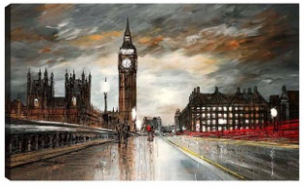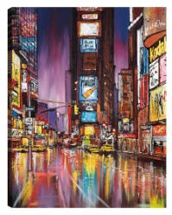  On Westminster Bridge Electric City  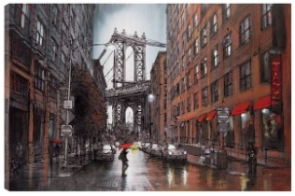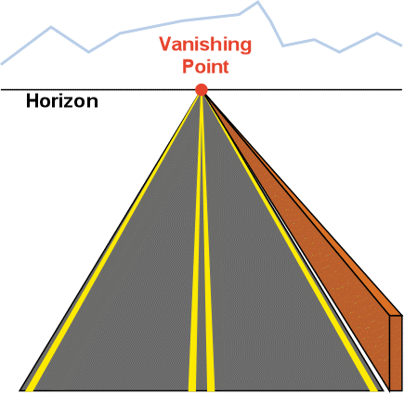  Jazz Hands Vanishing point and Horizon line.
- Vanishing point
- The point at which two parallel lines appear to converge
- Creates perspective
- Makes objects look like they are getting further away
- Horizon line
- Refers to where the sky separates from land and sea
- Represents the viewer’s eye level
- Suggests that the figures are the same height as the viewer of the picture
- Creating own drawing from a 3D perspective
- Size – How big or small something is
- Scale – Size of an object in relation to another
- Position – Arrangement of the image
- Proportion – Refers to the relative size and scale of elements
- Drawing own cityscape from a 3D perspective
- Examining images of a city
- Split paper into six equal parts and find horizon line and vanishing point
- Buildings get smaller as they approach the horizon line
- Picture must be parallel
- Evaluating artwork
- Similarities – things that are the same
- Differences – things that are different
- The wider influences of:
- Bayeux Tapestry, London Olympic Games 2012 Artwork by Paul Kenton, Similarities between Kenton and L.S Lowry, Impact of cityscapes on culture, creativity and wealth of our nation.
All about Paul Kenton
https://www.paulkenton.com/profile/
Drawing a 3D perspective
https://www.bbc.com/bitesize/clips/zvq6sbk
Drawing a 3D Cityscape
https://www.youtube.com/watch?v=twcFW0RyOO8

