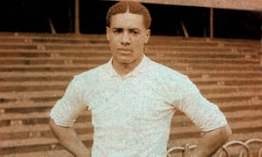
Year 6 – Cromwell, Warrington and the impact of local battles on the civil war and the monarchy.
POS: Pupils should be taught about Cromwell and discuss whether he was a genocidal dictator or a marvellous revolutionary and investigate the civil war battles that occurred in Warrington.
Prior content: Wars through time.
KEY EVENTS TIMELINE  1599 - Oliver Cromwell was born in Huntingdon, Cambridge.  1620 - Cromwell married Elizabeth Bourchier.  1628 - Cromwell was elected Member of Parliament for Huntingdon.  1642 - The English Civil War started. Cromwell raised a troop of cavalry in Huntingdon for Parliament.  1643 - Cromwell is appointed a colonel in the cavalry.  1648 - The Battle of Winwick in Warrington which contributes heavily to the end of the civil war. In December, Cromwell pushed for a full trial of Charles I who was to be charged with treason  1649 - January 30th, Charles was executed. Cromwell’s signature was third on the death warrant. Cromwell later becomes Lord Protector  1658 - September 3rd, Cromwell died—it was thought to be because of malaria. A state funeral was held. | 1: Battle-A period of fighting between 2 or more armies. Battles can be won or lost.  2: War- A sustained conflict between different countries or groups.  3: Civil War- A war between citizens of the same country  4: Lord Protector- The head of state- the person in charge of the country  5: Roundheads- The names given to supporters of the parliament of England during the English Civil War  6: Revolution- A forcible overthrow of a government, a monarchy or social order in favour of a new system.  7: Government- The group of people with the authority to lead a country or state  8: Monarchy- A form of government with a king or a queen at the head.  9: Dictator- A ruler with total power over a country, typically one who has obtained control by force.  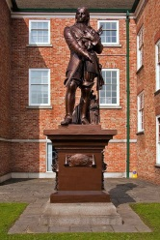  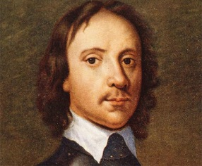  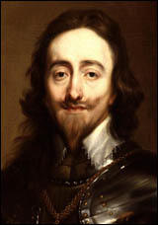  Statue of Cromwell in Warrington.
KEY PEOPLE
Oliver Cromwell - It is now over 350 years since Oliver Cromwell’s death - the Lord Protector's reputation is one which many people disagree about; for some he was a genocidal dictator and for others he was a marvellous revolutionary. He carried out two massacres in Ireland, yet helped end the English Civil War and was England’s ruler for 5 years, temporarily ending the rule of the monarchy. He also accused and executed 3000-4000 people for witchcraft; many people were not given a trial. 2 of his notable battles that occurred during the civil war occurred in Warrington.

Charles I was King of England, King of Scotland, and King of Ireland from 27 March 1625 until his execution in 1649. He was executed for treason and was beheaded after his defeat to Cromwell in the civil war.
St Elphin’s church which was badly damaged in the Battle of Winwick
