Year 6 Observational sketches (Still-life)
Prior Learning: Different types of lines, creating shadows, pencil techniques including linear, scumbling, side stroke and feathering.
Facts | Vocabulary
- Georgia O’Keefe  - Born in 1887 in Wisconsin, United States.  - Best known for her paintings of enlarged flowers and New York Skyscrapers. | - Georgia O’Keefe  - Still-life  - Outlines  - Structure  - Reflections  - Blending  - Eraser  - Vine charcoal  - Pressed charcoal  - Composition
- Still-life
- Objects shown in the paintings are things that are still in life
- Doesn’t typically focus on images of places or the outdoors.
- Can include cut flowers, fruit and vegetables.
- Composition
- Arrangement of elements within a work of art.
- Examining still-life art by Georgia O’Keefe
- The Apple Family
- Grapes on White Dish
- Oriental Poppies
- Still-life drawing techniques with pencil  - Set up still-life and draw lines to create outlines for 3D shape  - Examine abstract structure of arrangement and consider line, shape, tone, colour, pattern, texture and form.  - Sketch in the shapes of any shadows or reflections  - Creating tones to contrast from dark to light. | 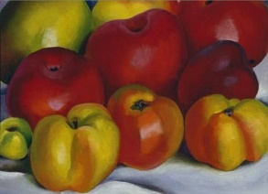  The Apple Family  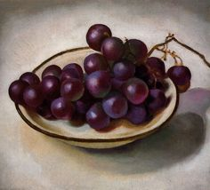  Grapes on White Dish  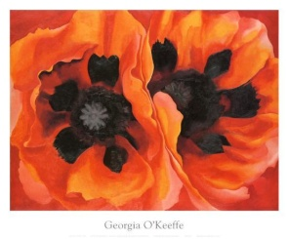  Oriental Poppies
- Using charcoal
- Can be used for shading and shadowing
- Different types including vine charcoal and pressed charcoal
- Pressed charcoal is much darker
- Shading and blending to create tones
- Can use an eraser to create patterns/lines
- Still-life drawing using charcoal
- Bold strokes and colours
- Range of lines
- Shading and creating shadows
- Creating own still-life drawing in the style of Georgia O’Keefe
- Sketch still-life using pencil
- Shading and blending using charcoal to create shadows and a 3D effect
- Use water paint to add colour to still-life artwork
- Evaluate the finished work by comparing with work of Georgia O’Keefe
- The wider influences of:
- Other still-life artists
- History of Still-Art
Information about Georgia O’Keefe and examples of her art work
https://www.tate.org.uk/kids/explore/who-is/who-georgia-okeeffe
All about still-life art
https://www.tate.org.uk/art/art-terms/s/still-life
Still-life drawing techniques
http://www.artyfactory.com/still-life/still_life_pencil.html
How to use charcoal
https://www.youtube.com/watch?v=_FEKpeEdCrE

