Year 6 – Textiles - Quilting
Prior Learning: sewing, threading a needle, using wool, cross stitch and running stitch, pattern, colour, shape, texture.
Facts | Vocabulary
- What is Quilting?  - The process of sewing two or more layers of fabric together to make a thicker padded material  - Usually done in three layers; the top fabric or quilt top, batting or insulated material and backing material  - Uses a needle and thread to join materials | - Quilting  - Padded  - Quilted garment  - Layers  - Insulated  - Fabric  - Batting  - Fibres  - Basting  - Cotton  - Polyester  - Binding  - Patchwork
- Examining examples of Block Quilting
- Patterns
- Colours
- Shapes

- Blanket Stitch
- Decorative stitch
- Sews two pieces of fabric together
- Known as the ‘secure stitch’
- Designing own Quilt  - Fabric – Felt, Cotton, Linen.  - Basting/Filling – Cotton or Polyester  - Colour Thread  - Stitches – Running Stitch, Cross Stitch and Blanket Stitch | Examples of Block Quilting:  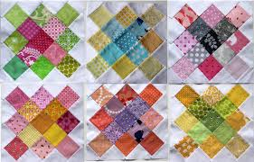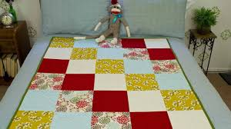  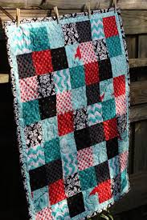  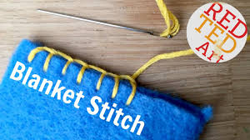  Blanket Stitch
- Cutting the fabric and creating patterns
- Large and small patterns
- Measuring out squares and cutting the shapes
- Use of colour – complimentary colours
- Sewing blocks together using running stitch
- Backing fabric has to be larger than the quilt and batting
- Basting the quilt
- The process of layering your quilt and pinning it in place before sewing
- Range of fibres such as cotton and polyester
- Sandwiched between backing layer and quilt
- Sewing and binding
- The binding is the border of fabric to help protect the seams and add more decoration
- Folding so that they overlap
- Blanket Stitch
- The wider influences of:
- uses of quilting, history of quilting, patch working, sewing techniques, impact on culture, creativity and wealth of our nation.
How to Blanket Stitch
https://www.youtube.com/watch?v=S9zegUYdPmg
How to Quilt
https://www.youtube.com/watch?v=vOWSp0mTTqE
What is Quilting?
https://www.createandcraft.com/gb/what-is-quilting
Quilting with Children
https://www.youtube.com/watch?v=WfdD4-WepJo

