Year 6 – Texture and Collage
Prior Learning: Collages by tearing and overlapping, colours, shapes, natural collages inspired by Andy Goldsworthy, pattern, line, form, shape, space, landscape sketching and painting, oil pastels and paints.
Facts | Vocabulary
- Megan Coyle  - Resides in Washington DC  - Artist and illustrator  - Creates collages from magazine strips using a process called ‘painting with paper’ | 1.Megan Coyle  2. objective  3. non-objective  4. painting with paper technique  5. mixed media  6. bubble wrap  7. cotton wool  8. wire
- Examining the work of Megan Coyle
- Riverside Loungers
- A Purple Cow’s Paradise
- The Washington Monument at Sunset
- Objective vs Non-objective collage
- Objective artwork refers to when the subject matter is easily recognisable
- Non-objective artwork is also known as abstract art, where the subject matter is not as recognisable.

- Painting with paper technique to create an objective collage
- Called “painting with paper” because she makes her collages look like paintings by manipulating pieces of paper.
- Only uses a pair of scissors, acid-free glue sticks, and magazine strips to make each collage
- Usually seals it by painting on a layer of clear varnish
- Mixed media technique  - When a variety of different textures and materials are used  - Can use paper, wool, newspaper, photographs, bubble wrap and/or wire  - 3D effect | 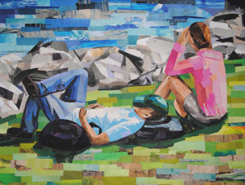  Riverside Loungers  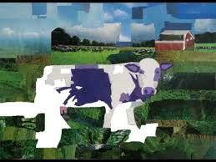  A Purple Cow’s Paradise  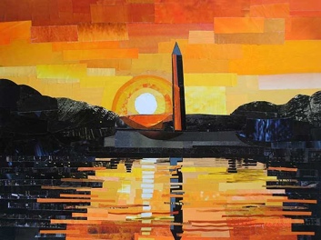  The Washington Monument at Sunset
- Creating a mixed media landscape collage
- Range of materials and mediums
- Objective collage
- Uses photographs
- Cutting and sticking
- Setting with varnish or PVA.
- The wider influences of:
- Mixed media techniques,
- Newspaper collages
- Uses of collage
All about Megan Coyle and her artwork
https://megancoyle.com/galleries/

How to Collage using magazine cut outs
https://www.youtube.com/watch?v=4OFvauUSxBk

