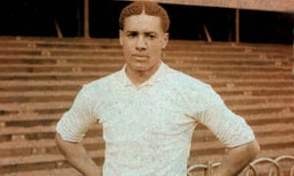
Year 6- Wars Through Time – Can Wars Ever Be Justified?
POS: Pupils should be taught about wars involving Britain since 1066 with an emphasis on WW1 and WW2 and how WW1 linked to WW2; they will investigate how the Battle of Dunkirk and the Battle of Britain were major turning points in British history; they will consider whether war can ever be justified.
Prior content: the Viking and Roman invasions of Britain
KEY EVENTS TIMELINE  Oct 1066- The Battle of Hastings  Aug 1642 – Sep 1651 – The English Civil War  June 1914- Archduke Franz Ferdinand of Austria assassinated.  July 1914- Austria/Hungary declare war on Serbia.  August 1914 - Germany declares war on Russia, France and Belgium. Britain declares war on Germany as we had a treaty to protect Belgium.  December 1914 – the Christmas truce.  July 1917- Battle of the Somme. 60,000 dead, wounded or missing in one day.  April 1917- US declares war on Germany.  March 1918 – Walter Tull dies.  November 1918- Armistice day – Germany surrenders  June 1919 - Treaty of Versailles signed. Conditions made lead to World War 2  1921 - Hitler becomes leader of the Nazi party.  1933 – Hitler becomes Chancellor of Germany; he later becomes a dictator.  1939 - Hitler invades Poland. Britain declares war on Germany as it has a treaty to protect Poland.  May 1940 – the Battle of Dunkirk.  July 1940 – the Battle of Britain.  December 1941 - Japanese bomb Pearl Harbour: America join the allies.  May 1945 – Germany surrender  August 1945 – America drop nuclear bombs on Hiroshima and Nagasaki – Japan surrender, marking the end of the war and peace across Europe. | 1: Treaty- An agreement between countries were they often agree to protect each other  2: Allies- People who support you in times of conflict  3: Enemies  4:Posthumous Medal- A medal given to someone after they die  5: Genocide- The deliberate killing of a large group of people  6:Racism- Expressing negativity towards someone because of their origin, colour or religion  7:Nuclear bomb- A bomb that uses nuclear energy to cause an explosion  8: Assassination- Murdering someone, often famous or powerful.  9: Freedom of Speech- The right to express your own opinions  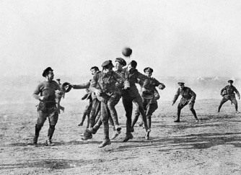  10: Justification- Giving reasons for something to be right or reasonable.  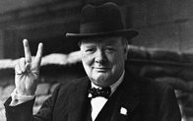  KEY PEOPLE  Adolf Hitler was a German politician and leader of the Nazi Party. He rose to power as the chancellor of Germany in 1933 and then as a dictator. During his dictatorship from 1933 to 1945, he initiated World War II in Europe by invading Poland on 1 September 1939 and the main person behind the holocaust (genocide of the Jews).  Neville Chamberlain - served as Prime Minister of the United Kingdom from May 1937 to May 1940.  Winston Churchill was the Prime Minister of the United Kingdom from 1940 to 1945, when he led Britain to victory in the Second World War; he served as Prime Minister again from 1951 to 1955.  Benito Mussolini was the leader of the National Fascist Party in Italy. He ruled Italy as the prime minister from 1922 to 1943; he was firstly democratically elected and then became a dictator.  Joseph Stalin was the communist ruler of the Soviet Union from the mid–1920s until 1953.  Franklin Roosevelt served as the 32nd president of the United States from 1933 until his death in 1945.  Harry S. Truman was the 33rd president of the United States from 1945 to 1953; he ordered the dropping of the nuclear bomb on the Japanese city of Hiroshima which lead to Japan’s surrender and the end of WW2
KEY PEOPLE

William the Conqueror was the first Norman ruler of England after winning at the Battle of Hastings and defeating King Harold II - he greatly influenced English culture through the import of the Norman (French) language and customs.
King Harold II – the king defeated and killed at the Battle of Hastings. Legend says that he was shot in the eye with an arrow.
Franz Ferdinand - the archduke of Austria was assassinated in 1914; he was the heir to the throne of Austria. His assassination in Sarajevo is considered the most immediate cause of World War I
Herbert Henry Asquith - served as Prime Minister of the United Kingdom from 1908 to 1916.
David Lloyd George - served as Prime Minister of the United Kingdom from 1916-22
Wilhelm II - was the last German Emperor and King of Prussia. He reigned from 15 June 1888 until his abdication on 9 November 1918 shortly before Germany's defeat in World War I.
Walter Tull - was both a professional footballer player and a soldier during World War One. He had to give up his career as a footballer to help out in the war, but he then became recognised as the first black officer to lead white British soldiers; many people think he should have been awarded a posthumous medal.
