Year 1 RE – Christianity Jesus
Curriculum Aims: This unit gives children the opportunity to explore the Christmas nativity story and to gain an understanding of why Jesus is believed to be a special baby. They should begin to think about why Christmas is a special religious time for Christians (as opposed to simply a cultural tradition of exchanging gifts). The focus of Jesus as a ‘gift’ will introduce children to the concept of the incarnation. They should also consider how, when and why humans might be vulnerable and in need of help. They should particularly focus on the idea that some people might not be able to help themselves and why helping those in need might be an important shared human value.
Prior Learning: They know about similarities and differences between themselves and others, and among families, communities and traditions.
Facts | Vocabulary
- Beliefs & Values  - To know a simple version of the nativity story.  - Talk about why Christians would say that Jesus is a special baby.  - Talk about how different characters in the nativity welcome the baby Jesus | Christian, God, Jesus, Nativity, Mary, Joseph, shepherd, Angel Gabriel, innkeeper, wise men, welcoming, vulnerable, Gold, Frankincense, Myrrh
- Living religious traditions
- Identify religious aspects of Christmas celebrations
- Talk about why Christmas is a special time for Christians
- Shared human experiences  - Consider how and why babies might be special and why they need love and care.  - Talk about the importance of looking after those who cannot help themselves | 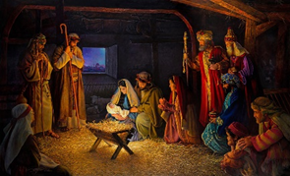  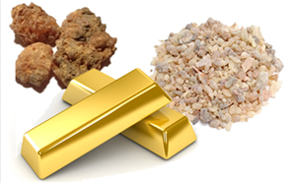  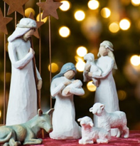
- Search for personal meaning
- Talk about their own beginnings and how they were welcomed into the family.
- Reflect on who has helped them in life so far.
Warrington Links :
Nativity Scene at the Golden Gates

Texts:
Nativity story
. http://www.reonline.org.uk/supporting/.
https://www.youtube.com/watch?v=FrTFAZPQxpE
Enrichment:
- Invite a person of Christian faith to talk about how they celebrate Christmas and the importance of Jesus to the Christian faith
- Open the book
- Make links with the Church

