Year 1 RE – Christianity Church
Curriculum Aims: In this unit children will explore how the rite of baptism shows that Christians belong to Gods’ family - the Church. They will identify symbols, items and people liked to baptism and will reflect on why, in some Christian communities, parents choose to have their baby baptised. This will build on their prior learning about Christian belief in God the Father and how religious beliefs might be expressed through symbolic images and actions. The focus of the enquiry is on belonging, sharing and learning within the practice of baptism and in pupils’ lives.
Prior Learning: They know about similarities and differences between themselves and others, and among families, communities and traditions.
Facts | Vocabulary
- Beliefs & Values  - To know that some Christians welcome babies into the God’s family (the Church) with baptism ceremonies  - To talk about what it might mean to belong to the Church family | Christianity, baptism, church, ceremony, family font, candles, godparents, certificate, belonging, cross, priest, minister, vicar.
- Living religious traditions
- identify features of baptism – eg. the font, candles, godparents
- talk about why parents might want to have their child baptised
- Shared human experiences  - talk about what is means to belong to a family  - talk about the role of families in raising children | 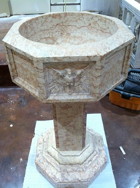  Baptism  Baptismal Font  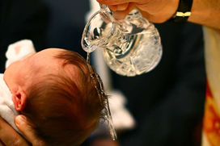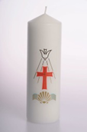  Baptismal Candle
- Search for personal meaning
- talk about their own identity as part of a family and part of the school community
Warrington Links :
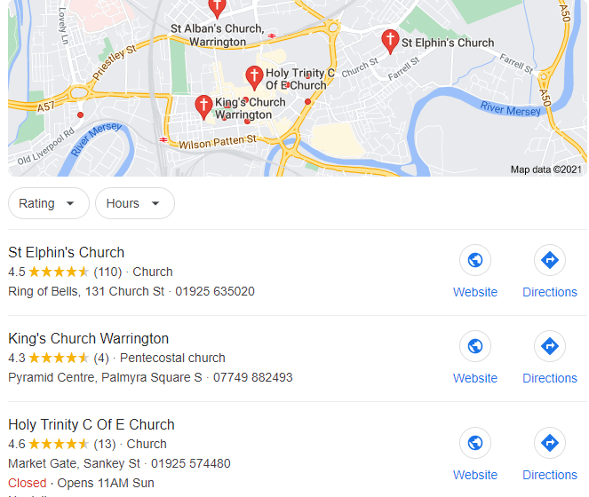
Texts:
https://www.bbc.com/bitesize/clips/zr34wmn
http://e4education.uk-virtualtours.co.uk/church/
Enrichment:
- Interview or home links with a Christian who has been baptised to share their experience
- A visit to a Church to identify symbols of Baptism
- A visit from a priest or vicar to discuss the role of Baptism

