Year 1 RE – Hindu dharma
Curriculum Aims: This unit gives children the opportunity to explore the Hindu concept of one God (Brahman) who can be understood and visualised in many forms. This unit should build on their prior learning about the use of symbolism to express religious beliefs. Children should be able to talk about how images of the deities in Hinduism are a visual representation of beliefs about God. Children should also have opportunities to think about the complexity of identity and how people may be seen in different ways according to their role and relationship. There will be opportunities for children to develop self-awareness of their own identity and roles.
Prior Learning: They know about similarities and differences between themselves and others, and among families, communities and traditions. Children will have explored simple representations of other faiths and celebrations in EYFS.
Facts | Vocabulary
- Beliefs & Values  - know that Hindus believe in one God in many forms  - know that Hindus believe that God is present in all living things  - suggest what Hindus might learn about God from the story of the blind men and the elephant | Hindu’s, Hinduism, God, statues, Murtis. Worship, symbols, deities, Brahman, Lakshmi, Ganesh
- Living religious traditions
- talk about how and why Hindus might use statues and images (murtis) in their worship
- suggest symbolic meanings expressed in the images

- Shared human experiences  - talk about the different ways that people can be seen and described  - consider how people might have multiple roles | 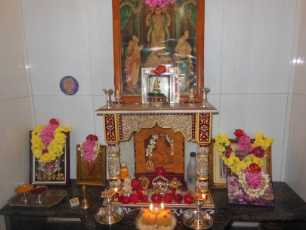  Hindu shrine  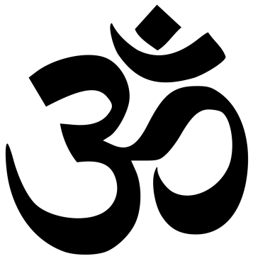  Hindu symbol – The Om  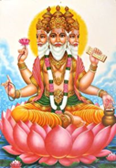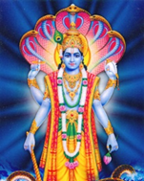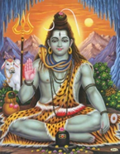  Shiva  Brahma  Vishnu
- Search for personal meaning
- reflect on how others might see them
- talk about the different roles that they might have (friend, child, brother/sister etc.)
Warrington Links :
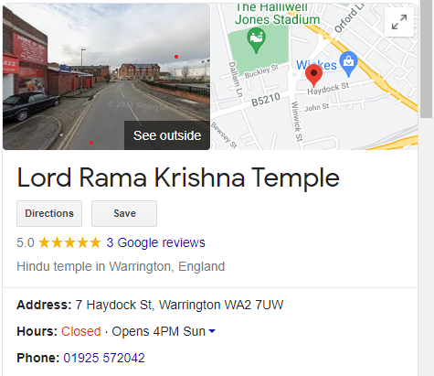
Texts:
Read the blind men and the elephant story
Enrichment:
- Invite a person of Hundu faith to visit and discuss traditional clothes linked to the Hindu faith
- Visit a Hindu temple to find out about the importance of Hindu shrines in worship

