Year 1 RE – Islam
Curriculum Aims: This unit enables pupils to examine the Muslim belief in Allah as creator. The focus is to encourage pupils to consider Allah’s role in creating and sustaining the world, and humankind’s response to Allah. Pupils should think about and reflect on their responsibility towards creation. They should begin to develop an understanding of how Muhammad (pbuh) is seen as a role model for Muslims and how the teachings of the Prophet might influence how and why a Muslim might care for the natural world. The experiences of the life of the prophet in this unit this should be explored through story. Pupils should have opportunities to discuss and demonstrate their understanding in a variety of ways. Pupils should also have opportunity to personally reflect on their own beliefs and values about the importance of caring for the natural world. They should consider their own responsibility and how they could actively contribute towards caring for the planet.
Prior Learning: Children will have explored different festivals and special times for believers of different faiths.
Facts | Vocabulary
- Beliefs & Values  - know that Muslims believe in one God (Allah)  - know that Muslims believe the world was created by God  - Talk about why Muslims might value the natural world | God, Allah, Muslim, created, creator, natural world, caretaker, steward, Khalifahs, respect, Prophet Muhammad (pbuh), environment,
- Living religious traditions
- know that Islam teaches that humans should be caretakers (stewards/Khalifahs) of the planet
- Suggest how Muslims might show respect for God by caring for the natural world

- Shared human experiences  - Talk about their own experiences and feelings about the natural world and what they have noticed about the way that humans treat it | Caring for our world.  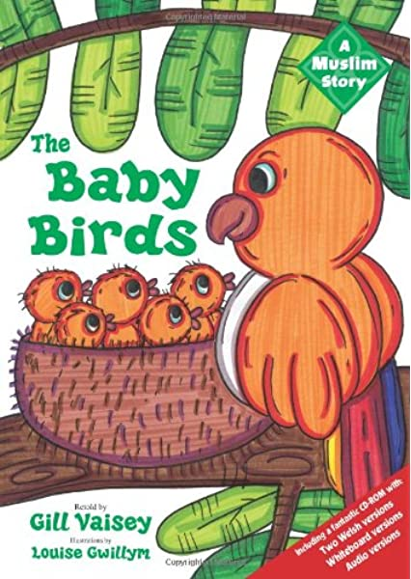  The Prophet and the Baby Birds
- Search for personal meaning
- Reflect on how they treat the natural world – and if they have a duty to look after it
Warrington Links :
http://warringtonislamicassociation.org.uk
Texts:
The Wonderful World Song https://www.youtube.com/watch?v=m5TwT69i1lU
BBCTeach clip of Islamic stories
https://www.youtube.com/watch?v=_bN7KIMmwlc
Read the Islamic story of the Baby birds
https://www.articlesoffaith.co.uk/faiths/islam.html?limit=all
Enrichment:
- Visit a local Mosque
http://warringtonislamicassociation.org.uk

