Year 1 RE – Judaism
Curriculum Aims: Focus Question: Why might some people put their trust in God?
In this unit, children will have the opportunity to explore Jewish beliefs about God, with a focus on why religious people put their trust in God and how this might be expressed.They will learn about the story of Noah and the symbol of the rainbow as God’s promise never to send a flood to destroy the world again. They will investigate the festival of Sukkot as an annual reminder to the Jewish community to be thankful to God for all he has done. Pupils will also have opportunities to talk about why promises and trust are an important aspect of human life. They will think about how we know whether or not people are trustworthy and reflect on their own values about the importance of being someone who is trusted by others.
Prior Learning: They know about similarities and differences between themselves and others, and among families, communities and traditions.
Facts | Vocabulary
- Beliefs & Values  - Give an example of a key belief (ie. that Jews believe in one God) and/or a religious story (the story of Noah and/or Abraham)  - Give an example of a core value or commitment (trusting that God will keep his promise | Jewish, Noah, Sukkot, celebration, God, promise, trust, Sukkah
- Living religious traditions
- Use some religious words and phrases to recognise and name features of religious traditions (eg. Sukkot, festival)
- Talk about the way that religious beliefs might influence the way a person behaves (eg. like Noah and Abraham, Jewish people should trust that God keeps his promises)

- Shared human experiences  - Notice and show curiosity about people and how they live their lives (finding out about Jewish festivals – thinking about the fact that people celebrate different celebrations in very different ways – eg. Sukkot)  - Notice that for many people, trust is an important part of human life | 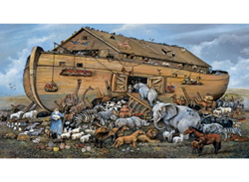  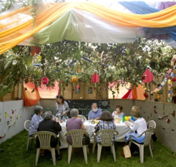  Noah and the Ark
- Search for personal meaning
- Ask questions (about the importance of trust and who they can trust/rely on in their own lives)
Warrington Links :
http://southmanchestersynagogue.org.uk
Texts:
Watch Jumpin’ Jerusalem- Sukkot https://www.youtube.com/watch?v=h_W1pGtlRsY
Read the story of Noah. If you have a toy ark/pairs of animals then the story could be acted out.
Enrichment: Visit a local synagogue

