Soweto – South Africa - Year 1
Context:
Soweto is a township in South Africa.
Concepts:
Place, space, environment , interconnection , change

Facts | Vocabulary
1.Soweto is a township in South Africa. | Township – an area similar to a town or city  Urban – built up and densely populated  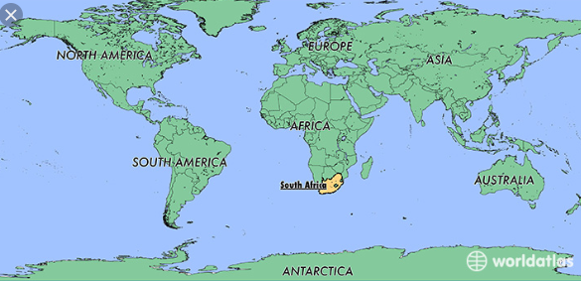  Settlement – a place where people establish a community  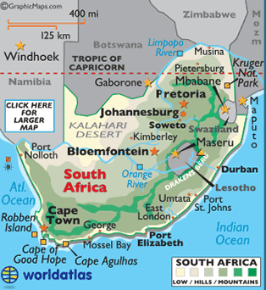  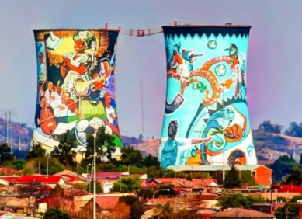  Orlando Towers
2.Soweto is an urban settlement or 'township' in South Africa, southwest of Johannesburg, with a population of approximately 1.3 million.

3.Soweto is composed of 26 small independent townships.

4. Physical Features - Are natural features such as trees, mountains, oceans, rivers, lakes.

5. Human Features - Are things that are built by humans such as bridges and roads.
6. Physical features of Soweto – Mountains, vegetation.
7. Human features of Soweto – highway, railway, houses, matchbox houses, shacks, shops, shopping malls, Orlando Towers.
8. Weather - Soweto’s summer lasts from September through April while its winter lasts from May to August. In Soweto, it is generally mild and sunny throughout the year. However, it can get very hot during Summer.
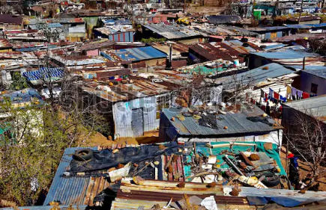
www.maps.nls.uk
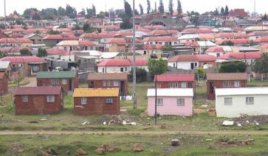
Matchbox houses Shacks

