Year 6 Religious Education and World Views – Is life like a journey?
Buddhism – What do we mean by a ‘good life’?
Curriculum Aims: This unit will enable you to explore the concept of a good life through considering what Buddhism teaches makes someone truly happy. You will find out about the life experiences that started Prince Siddhartha’s journey to becoming the Buddha and will reflect on how the teachings of the Four Noble Truths and the Eightfold Path impact the spiritual journeys and daily lives of Buddhists. You will have the opportunity to experience meditation and to reflect on their own life and happiness as they prepare for the change of leaving primary school.
You should be able to make reference to other religions and worldviews that they have studied when discussing how beliefs and values might give people guidance and support to enable them to live a ‘good’ life.
Prior Knowledge: This unit will build on your prior learning about life as a journey and deepen their understanding of how people might cope with change and difficulties in life.

Facts | Vocabulary
- Beliefs & Values  - The fourth Noble Truth teaches that, in order to achieve virtue, happiness and eventually Nirvana, the Eightfold Path should be followed.  - The Four Noble Truths – these contain the essence of Buddha’s teachings.  - The truth of suffering (Dukkha)  - The truth of the origin of suffering (Samudāya)  - The truth of the cessation of suffering (Nirodha)  - The truth of the path to the cessation of suffering (Magga).  - Prince Siddhartha – the founder of Buddhism. He left the comfort and safety of his Father’s palace and saw ‘Four Sights’ that were to change his life. As he looked on old age, sickness, death and holiness, he determined to search for the real answers to the meaning of life. | The Buddha – the founder of Buddhism (Prince Siddhartha).  The Four Noble Truths – these comprise the essence of Buddha’s teachings.  The Eightfold Path – the path Buddhists must follow to end suffering.
- Living Religious Traditions
- The Eightfold Path – this is the fourth part (Magga) of the Noble Truths. It gives Buddhists a path they can follow to end suffering. However, these are not steps but rather eight guiding principles that suggest the way to end suffering.
- Daily meditation is important for Buddhists in their aim of achieving nirvana and they often choose to start their day by meditating.
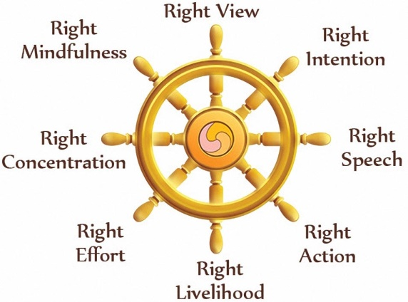

The Eightfold Path
- Shared human experiences
- Contentment- Is it the same as happiness or something different?
- Reflect on what you need to be happy.
- Search for personal meaning
- Ask and respond thoughtfully to questions about their own happiness – consider this as something that they are in control of
- Discuss the potential barriers to their happiness and what they can do to overcome these.
https://www.youtube.com/watch?v=TK-MbNj83NM
https://www.youtube.com/watch?v=TK-MbNj83NM and https://www.youtube.com/watch?v=bgcbQnL6-BQ are useful videos, but are challenging in places, so will need some discussion and explanation.
This may also be helpful https://www.clear-vision.org/Schools/Students/Ages-12-14/Four-noble-truths.aspx

