Year 6 Religious Education and World Views – Is life like a journey?
Christianity – Church: If life is like a journey, what’s the destination?
Curriculum Aims: If life is like a journey, what’s the destination?
You will learn about the effect that belief in salvation brought about by Jesus’ death and resurrection has. You will discover how the act of confessing sins and seeking reconciliation and forgiveness restores relationships with others and with God in the eyes of the believer, leading to faith in life after death. You will have opportunities to reflect on the importance of forgiveness to them.
Prior Learning: This builds on their prior learning about how Christians are guided to live.

Facts | Vocabulary
1. Beliefs and Values  - Christians believe that Jesus died to take away our sins and to restore the close relationship with God.  - Christians believe in salvation saving of human beings from sin and its consequences.  - Christians believe in life after death.  - Being able to ask for forgiveness and to forgive others is a central part of Christian faith. | Atonement – making amends for doing wrong.  Forgiveness – the action or process of forgiving or being forgiven.  Resolution – solving a problem.  Resurrection – in Christian belief, the rising of Jesus from the dead.  Eternal life – in Christian belief, spiritual existence after the death of the body.  Repentance – to feel sorry for a past action or mistake.  Confession – admitting to a wrongdoing.
2. Living Religious Traditions
- Christians try to atone (make amends for) their sins which will lead to them entering Heaven.
- Christians understand the importance of forgiveness and give examples of when this has happened in the bible.
3. Shared Human Experiences
- Christians have different opinions about the purpose of human life.
- Christians understand the importance of saying sorry and forgiveness in maintaining relationships with others.
4. Search for Personal Meaning
- To reflect on the beliefs and difficulties for forgiveness.
- To raise questions about the meaning and purpose of life.

 | 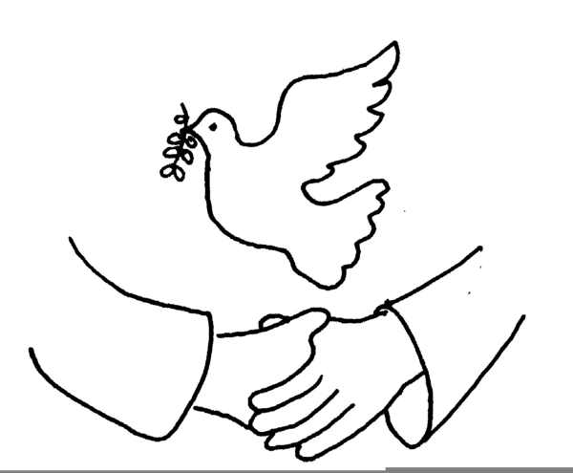
https://www.youtube.com/watch?v=V-YuMPnbVHw
https://reconciliationeducation.weebly.com/the-four-steps.html
Watch https://www.youtube.com/watch?v=V-YuMPnbVHw where some children explain what confession is and why Christians confess their sins.
Share https://reconciliationeducation.weebly.com/the-four-steps.html where the four steps of the sacrament of reconciliation are explained.
Watch https://www.youtube.com/watch?v=fXLiyY6II6Q where the sacrament is demonstrated
https://www.bbc.com/bitesize/guides/z2b36yc/revision/8 contains examples of Christians who have shown forgiveness in challenging circumstances

