Year 6 Religious Education and World Views – Is life like a journey?
Christianity God – How do Christians mark the ‘turning points’ on the journey of life?
Curriculum Aims: This unit enables you to explore the church as a community of believers and to examine how rites of passage reflect their commitment and relationship with God. The focus is on ‘is life like a journey’ so through this unit you will analyse beliefs, teachings and values and how they are linked by exploring the key sacraments in a Christian’s life. You should consider different dominations reflecting upon the importance of child baptism, confirmation and adult baptism. This can then be developed by demonstrating a self-awareness of their own personal development by considering their own life journey and the changes they will make as they make as they progress through life.
They should be able to make meaningful links with Christian beliefs about God as ‘Father’, a God who became incarnate in order to teach and save, a God who is both transcendent and personal.
Prior Knowledge: Pupils should be able to apply their understanding of the Christian concept of God from previous years.

Facts | Vocabulary
- Beliefs and Values  - The Baptism of Jesus (Matthew 3:11-17)– Christians believe that Jesus was baptised so that he could become like one of us. This shows his great humility. He set an example for us to follow. Jesus’ baptism was also an opportunity to show his authority as God confirmed he was his son.  - Baptism – this has been a symbolic way of joining the Church from the very start of Christianity. Water is used in baptism and is a symbol of washing away sin and the start of a new life.  - Symbols of Baptism – There are five symbols of baptism:  - The Cross – the universal symbol of Christianity.  - White clothing – white is the colour of purity, and wearing a white garment symbolises that the person now has a clean slate in the eyes of God.  - The Oil – a baptismal symbol of the Holy Spirit.  - Water – the Christian symbol of divine life, as well as a sign of purity and cleansing from sin.  - The Baptism Light – a candle is used to represent the light of Christ coming into the person’s life. | Rites of Passage – a ceremony or event marking an important stage in someone’s life.  Baptism – the Christian religious rite of welcoming a person (usually a child) into the Church.  Confirmation – the Christian religious rite and the final initiation for Christians into the Christian community.
- Living religious traditions
- Confirmation – another Christian rite of passage, wherein the Holy Spirit comes upon the person being confirmed. This typically takes place in early teenage years, when a child starts to be seen as an adult member of the Church. This is because they are now considered old enough to renew and confirm for themselves vows that were made on their behalf when they were baptised.
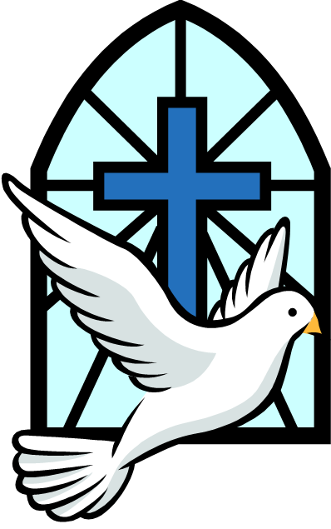

The Sacrament of Confirmation
- Shared Human experiences
- Discuss how people change during the course of their lifetime – and the key events that humans might mark on the journey of life
- Consider the value of celebrating landmarks in life – for individuals and communities
- Search for personal meaning
- Ask and respond thoughtfully to questions about how you have changed during their life so far – and how you might continue to change
- Discuss where you might find wisdom and guidance to help prepare you for the changes and responsibilities of different stages of life
https://www.youtube.com/watch?v=9_dr9njVzKM

