Year 6 Religious Education and World Views – Is life like a journey?
Christianity Jesus: Why do Christians believe that Good Friday is good?
Curriculum Aims: This unit enables you to explore the events of Holy Week and Easter Sunday in the Christian religion. You will focus on Christian beliefs about suffering and how these are responded to and commemorated through the events of Holy Week. Through study of Eucharist in different denominations, you will identify how Christians view the death and resurrection of Jesus as a source of guidance and comfort. You will have opportunities to reflect on whether suffering can make a person stronger and who or what they can turn to when facing difficulties.
Prior Knowledge: This builds on your prior knowledge of Lent, the Easter Story and the concept of Jesus’ sacrifice.

Facts | Vocabulary
- Beliefs & Values  - Holy Week – This is the most important week in the Christian calendar, detailing the events leading up to the death and resurrection of Jesus. Events during Holy Week include:  - Palm Sunday – Jesus arrives in Jerusalem riding on a donkey. Crowds of people come out of the city to greet him, throwing down palm branches on the road.  - Maundy Thursday – Jesus ate the Passover meal with his disciples, breaking bread and drinking wine. Christians refer to this meal as the Last Supper.  - Good Friday – Jesus dies on the cross. This is a day of mourning in Church. During special Good Friday services, Christians remember Jesus’s suffering and death on the cross, and what this means for their faith.  - Easter Sunday – Jesus rises from the dead. This is called the resurrection.  - Christians have important beliefs about the suffering, death and resurrection of Jesus.  - Importance of Good Friday – because it celebrates what they believe to be the most momentous weekend in history. They remember Good Friday as the day Jesus willingly suffered and died on the cross as the ultimate sacrifice for all of our sins. | Holy Week – the week leading up to Easter beginning with Palm Sunday.  The Eucharist – the Christian service, ceremony or sacrament remembering the Last Supper, in which bread and wine are consecrated and consumed.  Resurrection – the rising of Jesus from the dead.  Sacrament – a religious ceremony or ritual.  Consecration – when bread and wine is represented as the body and blood of Christ.
- Living Religious Traditions
- Eucharist – The Eucharist, also known as Holy Communion, is a sacrament that commemorates the Last Supper.
The most important element of the Eucharist is the bread and wine.
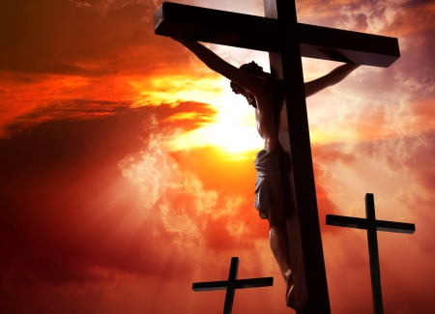

Good Friday
- Shared Human Experiences
- Understand what is meant by the terms guide, comfort, strength, suffering, struggle and courage and consider how people become stronger overcoming these difficulties.
- Search for personal meaning
- To raise questions and discuss the extent to which they agree that ‘suffering makes you stronger’.
- To discuss own experiences and attitudes towards the importance of having companionship on the journey of life.
https://www.youtube.com/watch?v=-M8Yesnt1V8
Watch ‘My Religion, My Life: Christianity’ https://www.youtube.com/watch?v=MK2o-mhBfuc
Watch the Lego Easter Story at https://www.youtube.com/watch?v=-M8Yesnt1V8

