Year 6 Religious Education and World Views – Is life like a journey?
Hindu Dharma: Is there one journey or many?
Curriculum Aims: An understanding of the belief that dharma can change during the course of life and that the religious duties of a child are seen as different to those of an adult with family responsibilities or an elderly person. You will be able to build in their prior learning about the concept of ‘dharma’ within Hinduism. You will develop an understanding of the belief that dharma can change during the course of life and that the religious duties of a child are seen as different to those of an adult with family responsibilities or an elderly person. You will be able to explain how performing dharma would have an impact on a person’s karma – and how this then links with Hindu beliefs about the cycle of life, death and rebirth.
You will have opportunities to explore Hindu beliefs about reincarnation of the soul and the ultimate aim of Moksha (liberation from rebirth).
Prior Learning: To understand the way a Hindu may live based on their beliefs on reincarnation.

Facts | Vocabulary
- Beliefs & Values  - Hindu beliefs about the cycle of samsara – the view that the soul (the atman) is in a continuous flow of life, death and rebirth – with an eventual aim of reaching Moksha (freedom from samsara).  - Reincarnation is a major belief in the Hindu religion. Hindu’s believe that death does not necessarily mean the end.  - Law of karma and the process of samsara might affect a Hindu’s sense of purpose in life. | Reincarnation – the rebirth of a soul in another body.  Samsara – the cycle of death and rebirth to which life in the world is bound.  Ashramas – any of the our stages of an ideal life, ascending from the status of pupil to the total renunciation of the world.  Law of Karma – the belief that every action you take will have an equal reaction. “If you plant wholesome seeds, you will grow wholesome fruit.”
- Living Religious Traditions
- Four Ashramas – these are the four stages of life according to the Hindu religion. They are: Brahmacharya (student), Grihastha (householder), Vanaprastha (retired) and Sannyasa (renunciate).
- 16 Samskaras – these are 16 different rituals that Hindu’s believe must be completed in a lifetime.
- The Sacred Thread ceremony (the Upanayana) which celebrates the child being seen as responsible enough to take on religious duties.
- Shared Human Experiences
- Reflect on the special milestones that we might celebrate during a person’s lifetime.
- Reflect on how our rights, responsibilities and relationships with others might change as we go through life.
- Search for Personal Meaning
- Ask and respond thoughtfully to questions about their own journey of life.
- Consider how events and influences so far have made them the person they are today and what has been important learning to prepare them for the future.
 | 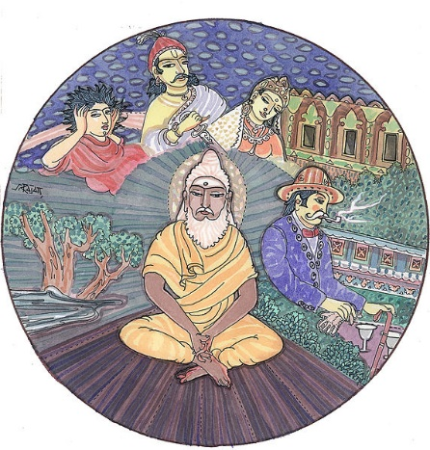
Reincarnation Video:
https://www.youtube.com/watch?v=Uq6_HUMtQtI
Focus on the Sacred Thread ceremony (the Upanayana) which celebrates the child being seen as responsible enough to take on religious duties. https://www.bbc.com/bitesize/clips/zmmgkqt

