Year 6 Religious Education and World Views – Is life like a journey?
Islam: What is Hajj and why is it important to Muslims?
Curriculum Aims: This unit enables you to explore the Five Pillars of Islam and how these beliefs and values impact on the life of a Muslim. Pupils should have opportunities to deepen their understanding by considering the pilgrimage to Mecca and completing Hajj. You will explore what is means to be a Hajji, reflecting on the personal journey a Muslim will make both physically and spiritually. You will be able to explain how a journey might change someone even after the journey itself is over. You will also consider their own life experiences and suggest how their lives have changed. You should consider the challenges that people may face during the journey of life and the support that may be needed as they move through their own life journey.
Prior Knowledge: To understand the importance of Hajj to Muslims.

Facts | Vocabulary
- Beliefs & Values  - The 5 Pillars – they consist of:  - Shahadah: sincerely reciting the Muslim profession of faith.  - Salat: performing ritual prayers in the proper way five times each day.  - Zakat: paying an alms (or charity) tax to benefit the poor and needy.  - Sawm: fasting during the month of Ramadan.  - Hajj: pilgrimage to Mecca.  - Muslims use the term Ummah for the worldwide community of Islam. Ummah is important to Muslims and how Muslims can support each other in times of difficulty. | Hajj – an annual pilgrimage made by Muslims.  The 5 Pillars – the five obligations that every Muslim must satisfy in order to live a good and responsible life according to Islam.  The Ummah – the whole community of Muslims.
- Living Religious Traditions
- Hajj is the annual pilgrimage made by Muslims to the holy city of Mecca in Saudi Arabia, in the Middle East. It takes place during Dhu al-Hijjah, which is the final month of the Islamic calendar.
- Every year, millions of Muslims from across the world make the journey to Mecca.
- Mecca is the place where the Islamic religion started. It is significant for two reasons:
- It is where the prophet Muhammad was born.
- It is where he received the first revelations from Allah that went on to become the Qur’an.
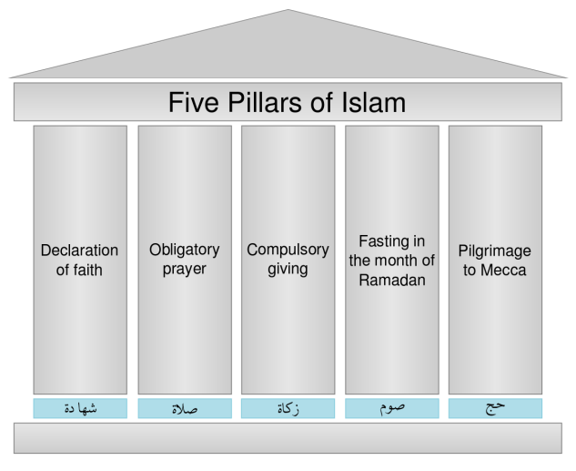

The Five Pillars of Islam
- Shared Human Experiences
- Discuss the various events that might happen on the journey of life and how people might change over the course of their life
- Consider what support people might need on life’s journey
- Search for personal meaning
- To ask and respond thoughtfully to questions about their own journey of life – consider how they have changed so far, how they will continue to change and the support and guidance that might be needed.
https://www.bbc.com/bitesize/topics/zpdtsbk/resources/1
Watch the religions of the world religions clip- https://www.youtube.com/watch?v=H9U8T8x1AhQ
Watch clip from ‘My life, my religion’ about Hajj: https://www.bbc.co.uk/programmes/p02mwk0y or ‘A trip to Mecca’ https://www.bbc.com/bitesize/clips/z9vcd2p

