Year 3 RE – Christianity The Church
Curriculum Aims: What do Christians mean by the Holy Spirit?
In this unit pupils will explore the Church as a community of people inspired by the Holy Spirit. This should build on their prior learning about the beliefs, values and symbols that unite the worldwide Christian community and the importance of worship. Pupils will learn about what Christians mean by the Holy Spirit and how this might inspire Christians to express their beliefs and values in different ways. There are also opportunities to explore how and why creative abilities such as music and art might be used to express ideas and talents.
Pupils should also reflect on their own unique skills/talents/qualities and how they use these. They should recognise that these ‘gifts’ are often inspired by someone or something.

Prior Learning:

Facts | Vocabulary
- Beliefs & Values  - Know what Christians mean by the Holy Spirit  - Suggest how belief in the Holy Spirit as God’s presence in the world might have an impact on individuals and communities  - Identify Christian values exemplified in the gifts/fruits of the Spirit | Disciples, discipleship, Jesus, mission, charity, Holy Spirit, presence, denominations, Pentecost, procession of witness, worship, apostles, symbols, flame, dove, qualities.
- Living religious traditions
- Identify how beliefs about the Holy Spirit might influence forms of worship in a range of Christian denominations
b. Describe how and why Pentecost is celebrated
c. describe why some Christians might take part in a procession of witness
- Shared human experiences  - describe aspects of being human that we should be proud of  - discuss what it means to be a successful human – and the different measures of success that might be applied | 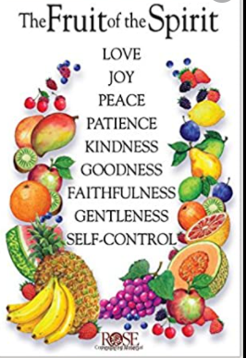  Fruits of the Holy Spirit
- Search for personal meaning
- discuss their own sense of value and what is good/unique about being them
- reflect on the people that they value in their lives – and how they show their appreciation
Links :
- Watch/listen to ‘What have you done today to make you feel proud?’ https://www.youtube.com/watch?v=LEoxGJ79PMs
- Ask children to think about the lyrics of a Christian song such as ‘Colours of Day’ https://www.youtube.com/watch?v=mw-7CJhlbp0 and how it might link with what they have learned about the Holy Spirit. If your school subscribe to ‘Fischy music’ this is also a good example https://www.fischy.com/songs/bring-it-all-to-me-2/
Texts:
- Read/watch the story of the first Pentecost: https://www.youtube.com/watch?v=IqG_lvZhU-A

Enrichment:

