Year 3 RE – Christianity God
Curriculum Aims: How (and why) have some people served God?
This unit enables pupils to explore Christian teachings and examples of people who have followed the word of God. They will investigate the prophets of the Old Testament and consider why these people chose to listen to God and how they put their beliefs into action. Pupils will also explore ways in which Christians today might follow God’s word and live a life of service – serving God and the community. They might look at inspiring Christians such as Dr Barnardo, Archbishop Desmond Tutu, William Booth and the work of the Salvation Army.
Children should have opportunities to discuss role models in their own lives and how/why some people have inspired them. They may also consider the idea that all people are inspired by others in some way – that the people they look up to will in turn look up to and follow someone who inspires and guides them.
They should be encouraged to make links with prior learning about the Christian concept of a God who has a special relationship with humanity; that God is described as creator and sustainer. One way that God is believed to sustain the world is through revealing his messages to the Prophets.

Prior Learning: Bible Stories and God as Creator of the Universe
Facts | Vocabulary
- Beliefs & Values  - Know that the Abrahamic faiths believe in prophets(and that many of these are shared across the three religions)  - Identify Christian beliefs and values contained within stories of the prophets (eg.Noah, Abraham, Moses,Jonah)  - Suggest why these prophets chose to listen to and follow God | Abrahamic faith, God, prophets, Noah, Abraham, Moses, Jonah, devote, role model, vocation
- Living religious traditions
- Identify Christians who might be described as people
who listened to and followed God
- Describe how and why some Christians might devote their lives to serving God
- Talk about what is meant by a sense of vocation

- Shared human experiences  - Identify inspirational people/role models for the world today  - Describe the qualities that inspirational people might have | 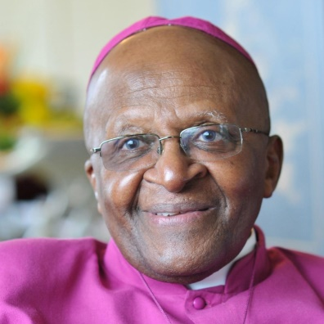  Archbishop Desmond Tutu
- Search for personal meaning
- Discuss who makes a good role model and why
- Raise and discuss questions about following others –including both positive and negative responses
Links :
KS2 resources for teaching about the Salvation Army can be found on their website https://www.salvationarmy.org.uk/religious-education#Primary Resources

Texts:
Read some of the stories of the Prophets from the Old Testament (eg. Noah, Abraham, Moses, Jonah) – there are a range of versions available that are suitable for children

Enrichment:
- Invite in the leader of a local church to talk to the children about the Christian concept of having a vocation. Investigate how a church leader might serve the local church and community – make links with the idea of serving God.

